***RAK - SD***

**Technical Design Forms**

Document Version: 1.0

Document Release Date: 27th May, 2024

**Only for internal use**

Table of Contents

1. Introduction: 3

1.1 Purpose of the document 3

1.2 Scope of the document 3

1.3 Overview 3

2. Table details: 3

2.1. Table Types 22

2.2. Structure details 22

2.3. Program Details 48

2.4. Global Class details 48

2.5. Enhancement details: 56

2.6. Smart form Details: 57

# Introduction:

## Purpose of the document

The purpose of this document is to describe the Technical Design of Forms at AGM-ECC project.

## Scope of the document

This document contains the technical description and design of Forms. It’s based on the referring and preceding Functional Design for RICEF Objects.

## Overview

This interface will produce JSON files in a format that is compatible with the Taxilla API, which will then call a government (ZATCA) web service to provide the E-invoice bill details.

# Table details:

|  |  |
| --- | --- |
| **Table Name** | **Short Description** |
| ZSD_T_PARAM_TAB | Parameter Table |
| ZSD_T_EINV_HT | Table for E-Invoice Details - To Store all master data of sap which is used to send the header details in JSON |
| ZSD_T_EINV_IT | Table for E-Invoice Details - To Store Transaction data of sap which is used to send the item details in JSON |
| ZSD_T_ZINV_CRED | E-Invoice Credentials - Table to store Client Id & Client Secret |
| ZSD_T_EIN_QR | Storing QR code - Table to Store QR Code details |
| ZSD_T_EIN_TOKEN | E-Invoice Tokens - Table to Store Token Details |
| ZSD_T_ZEIN_URL | EIN APIs - Table for URL Maintenance |
| ZSD_T_HT_ALW | Table for E-Invoice Details - Stores Header level allowance charges Data |
| ZSD_T_IT_ALW | Table for E-Invoice Details - Stores Item level allowance charges Data |
| ZSD_T_XML_RES | XML Response and Download - Table to store XML response |
| ZSD_T_ZINV_HT | Table for E-Invoice Details - Response Header Data |
| ZSD_T_ZINV_IT | Table for E-Invoice Details - Response Item Data |
| ZSD_T_ZINV_ALWC | Allowance Charges - Response Allowance Charges |
| ZSD_T_CONDITIONS | Conditions Type |
| ZSD_T_EIN_LOG | eInvoice Generation Log - Log Table to check the status of documents |

* **ZSD_T_PARAM_TAB: -** Parameter Table to active Enhancement
  + **Package: - ZEINV_RAK**
  + **Delivery Class: - A**
  + **Data Browser/Table View: - Display/Maintenance Allowed**

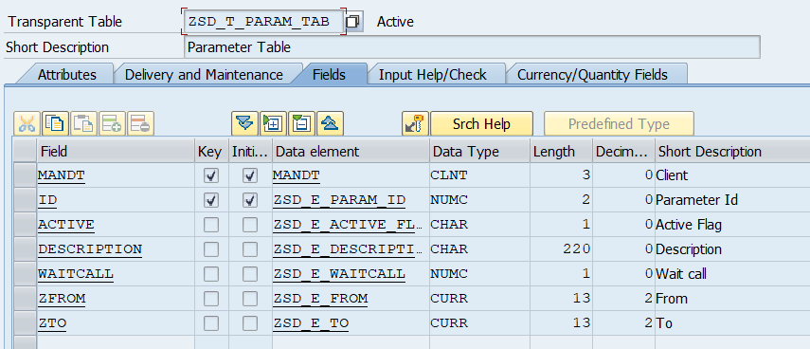

**Currency/Quantity Fields: -**

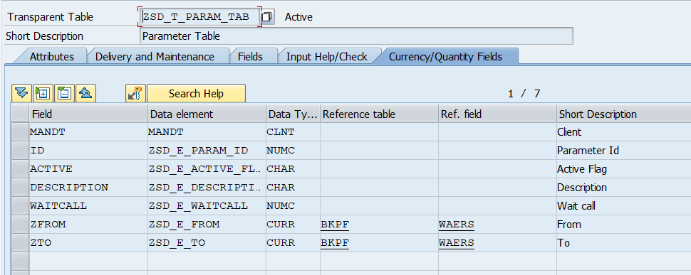

* **ZSD_T_EINV_HT: -** Table for E-Invoice Details
  + **Package: - ZEINV_RAK**
  + **Delivery Class: - A**
  + **Data Browser/Table View: - Display/Maintenance Allowed with Restrictions**

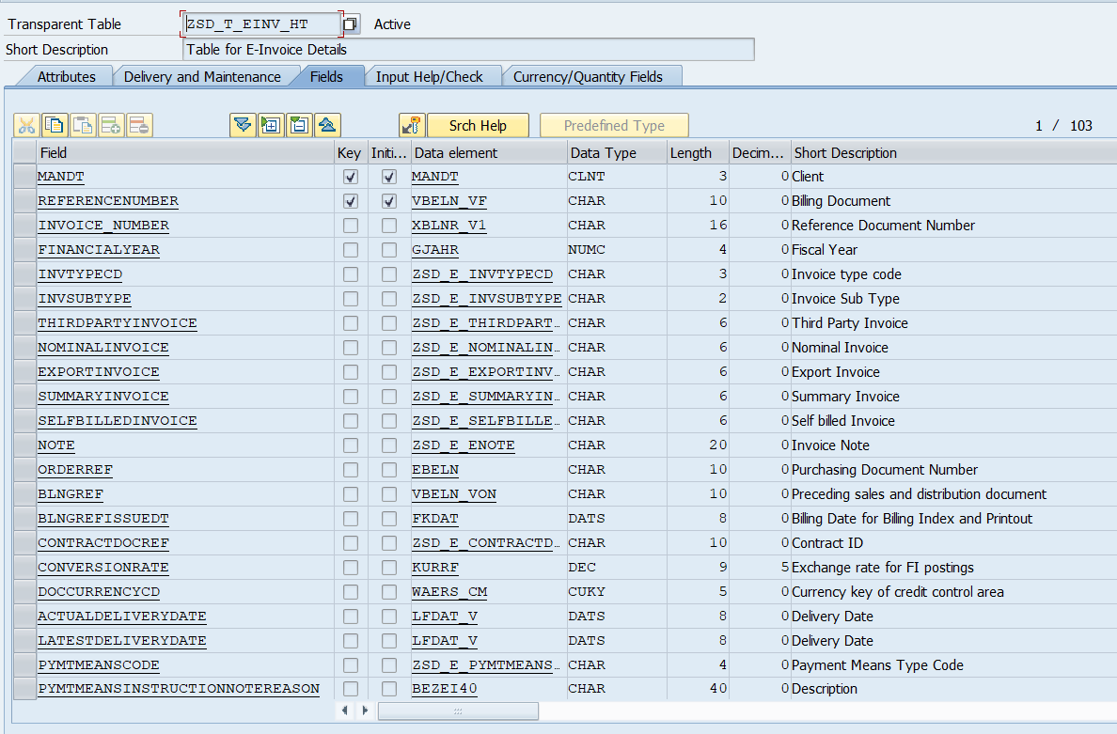

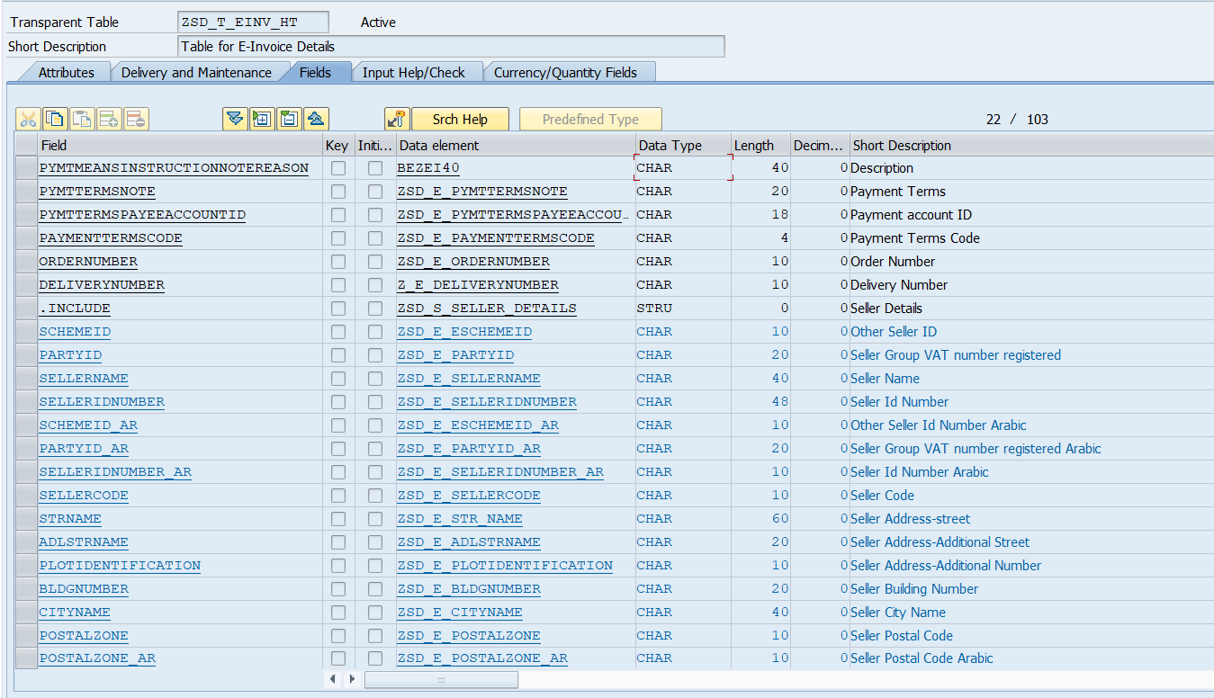

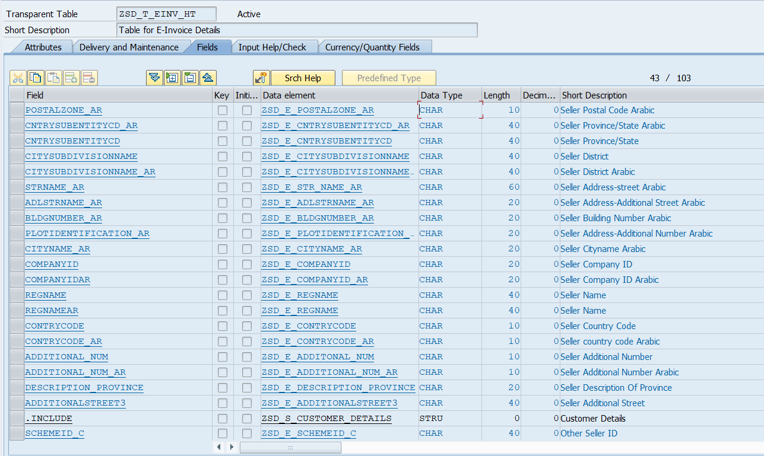

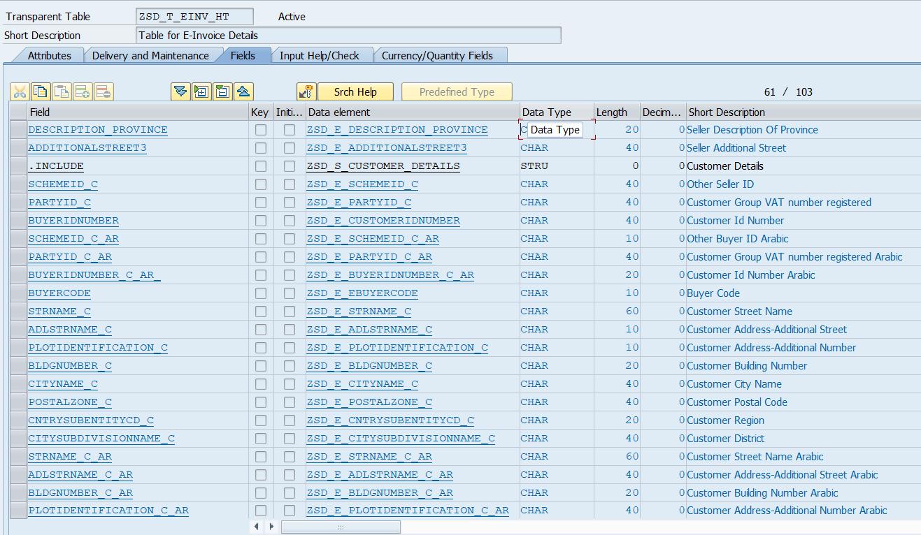

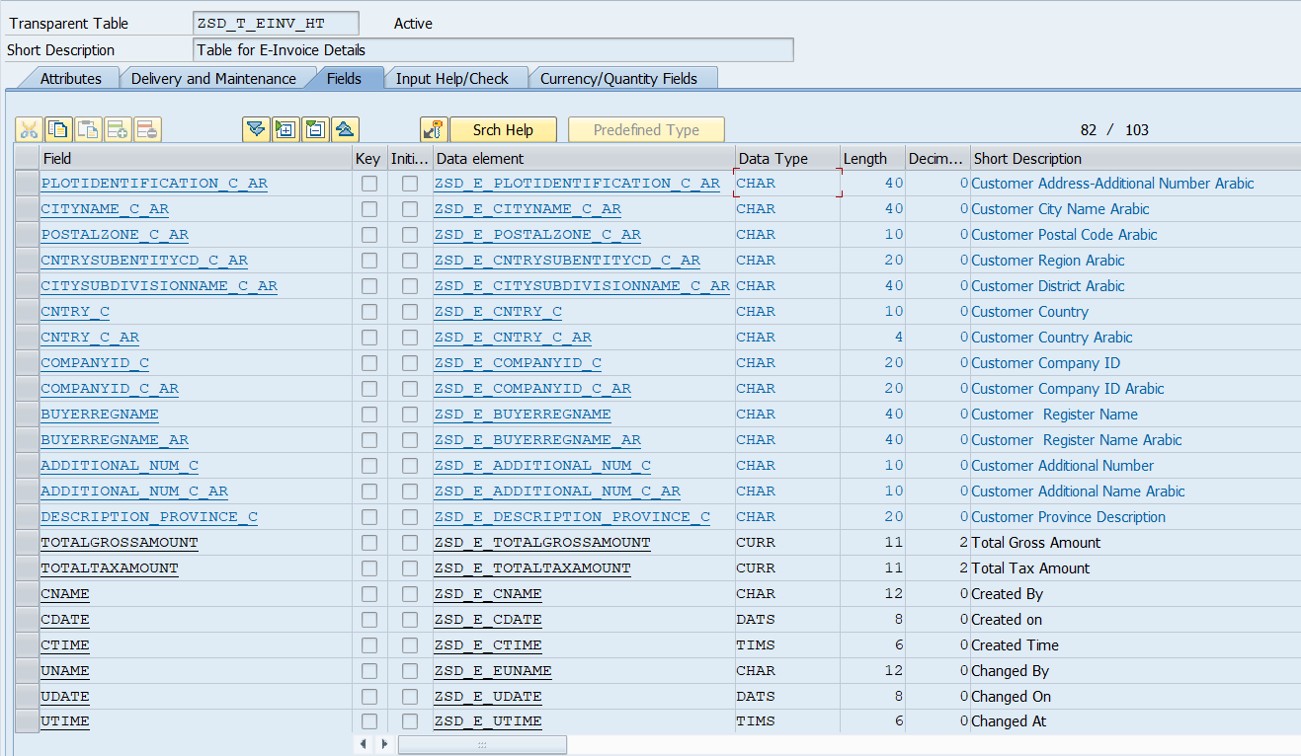

**Currency/Quantity Fields: -**

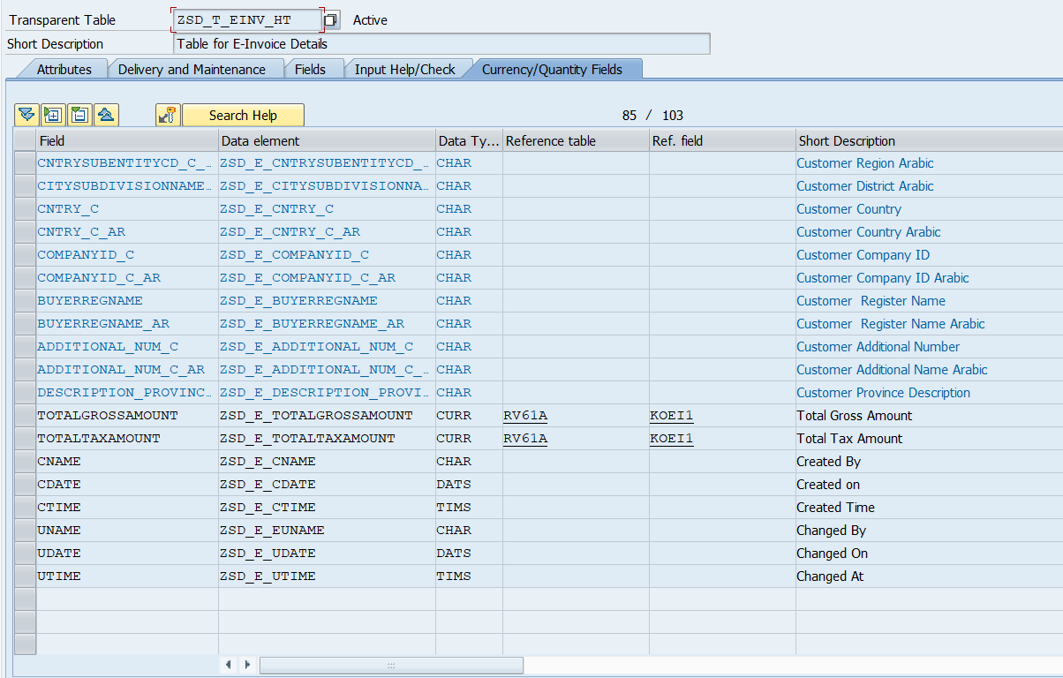

* **ZSD_T_EINV_IT: -** Table for E-Invoice Details
  + **Package: - ZEINV_RAK**
  + **Delivery Class: - A**
  + **Data Browser/Table View: - Display/Maintenance Allowed with Restrictions**

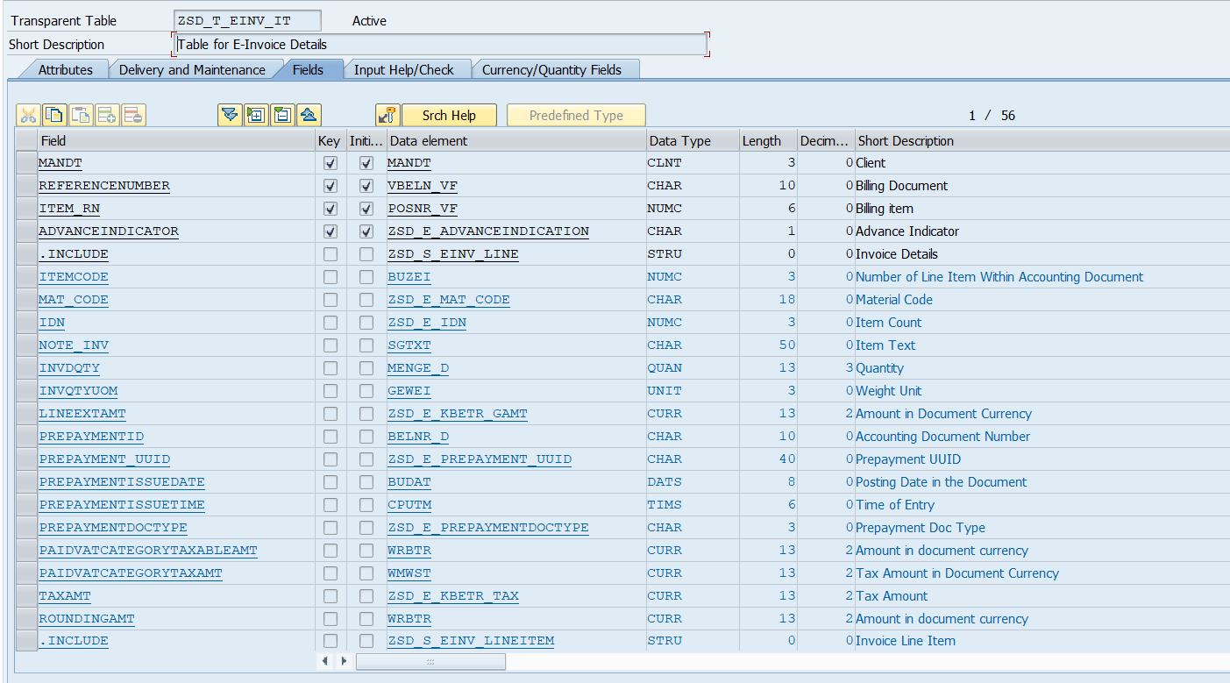

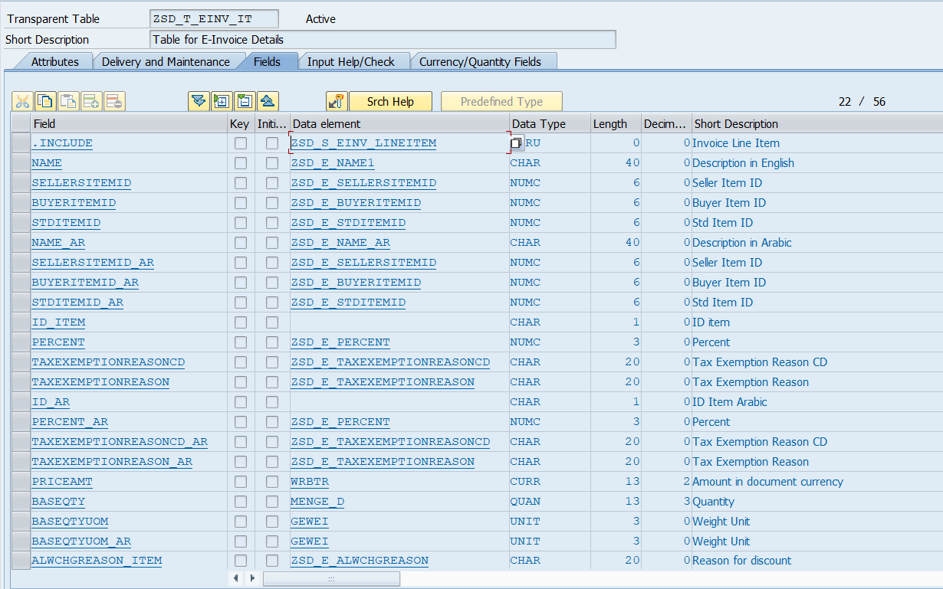

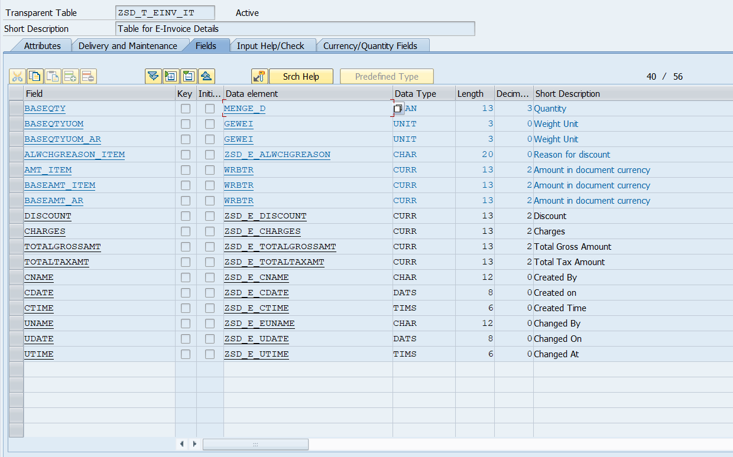

**Currency/Quantity Fields: -**

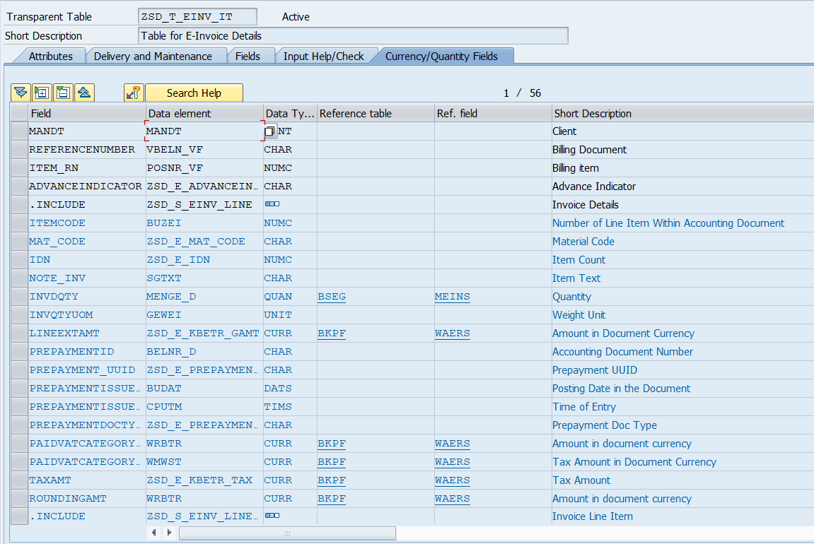

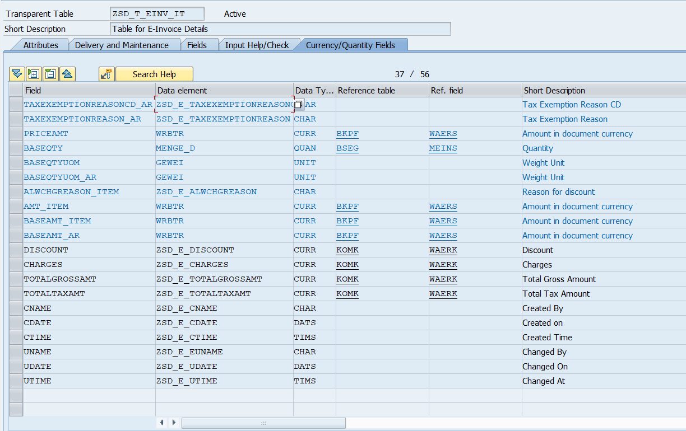

* **ZSD_T_ZINV_CRED: -** E-Invoice Credentials
  + **Package: - ZEINV_RAK**
  + **Delivery Class: - A**
  + **Data Browser/Table View: - Display/Maintenance Allowed**

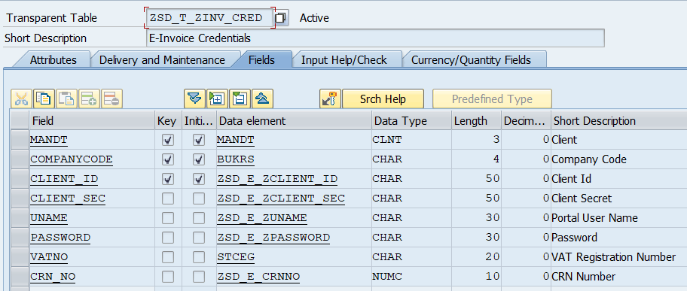

* **ZSD_T_EIN_QR: -** Table for E-Invoice Details
  + **Package: - ZEINV_RAK**
  + **Delivery Class: - A**
  + **Data Browser/Table View: - Display/Maintenance Allowed with Restrictions**

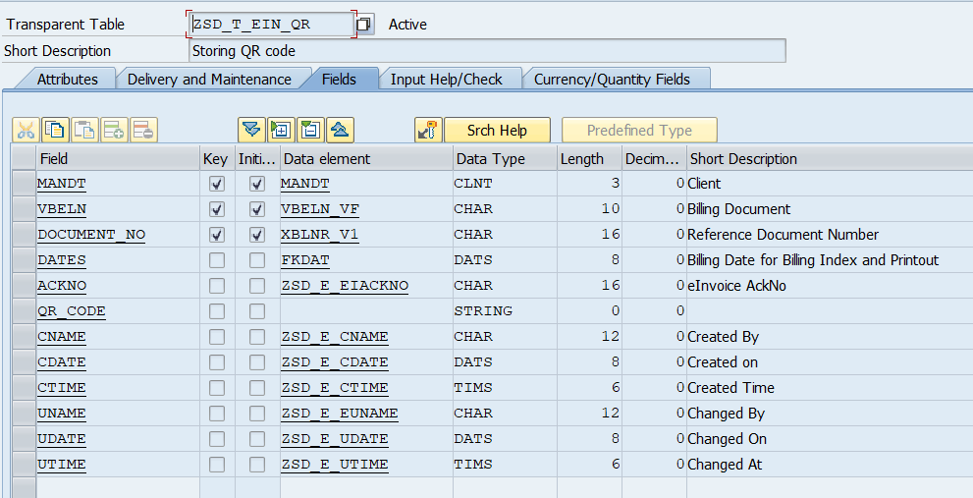

* **ZSD_T_EIN_TOKEN: -** E-Invoice Tokens
  + **Package: - ZEINV_RAK**
  + **Delivery Class: - A**
  + **Data Browser/Table View: - Display/Maintenance Allowed with Restrictions**

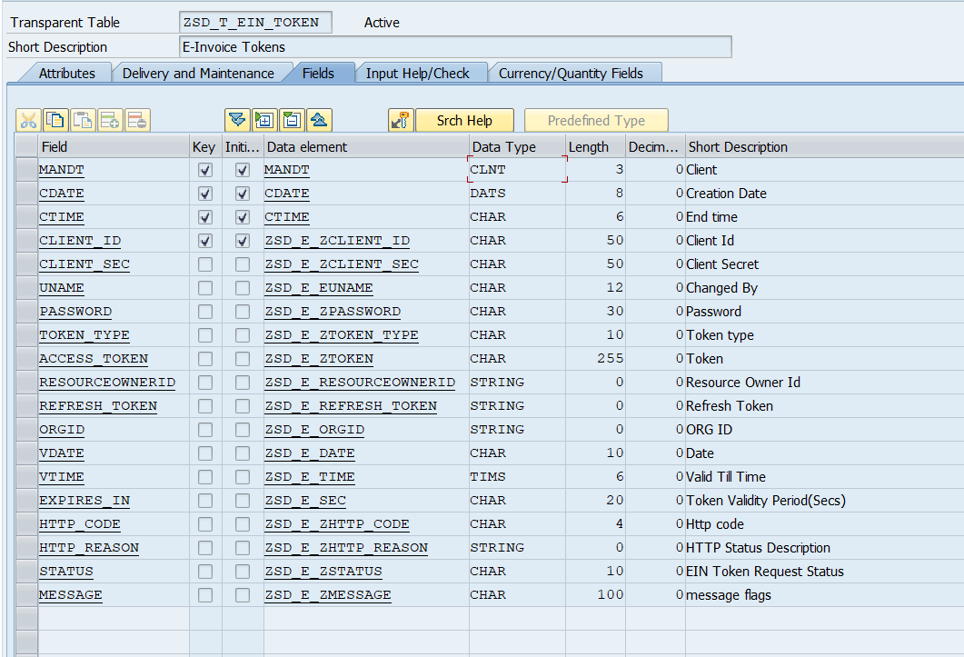

* **ZSD_T_ZEIN_URL: -** EIN APIs
  + **Package: - ZEINV_RAK**
  + **Delivery Class: - A**
  + **Data Browser/Table View: - Display/Maintenance Allowed**

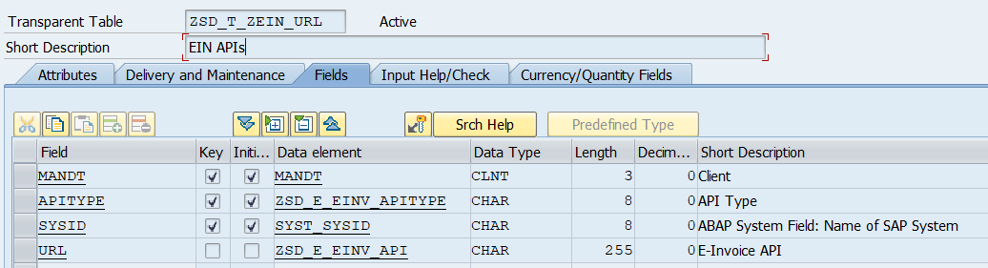

* **ZSD_T_HT_ALW: -** Table for E-Invoice Details
  + **Package: - ZEINV_RAK**
  + **Delivery Class: - A**
  + **Data Browser/Table View: - Display/Maintenance Allowed with Restrictions**

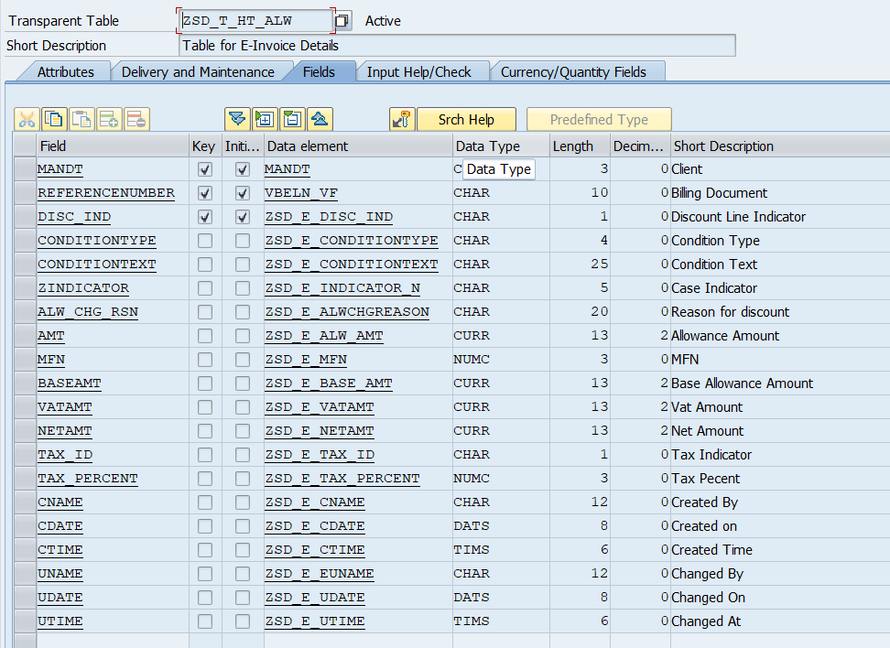

**Currency/Quantity Fields: -**

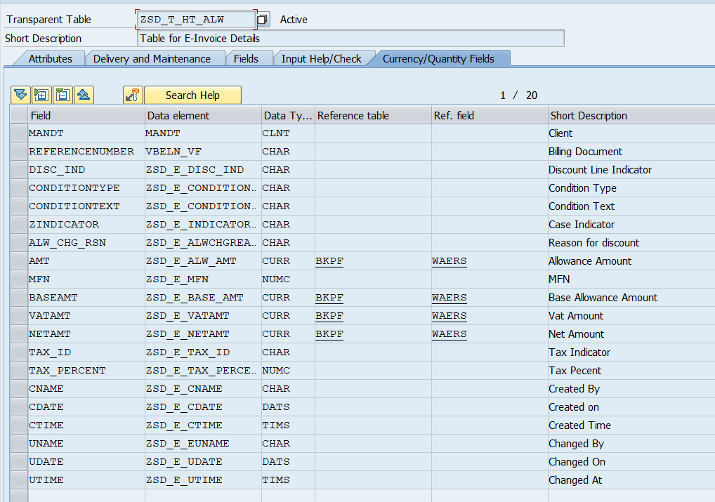

* **ZSD_T_IT_ALW: -** Table for E-Invoice Details
  + **Package: - ZEINV_RAK**
  + **Delivery Class: - A**
  + **Data Browser/Table View: - Display/Maintenance Allowed with Restrictions**

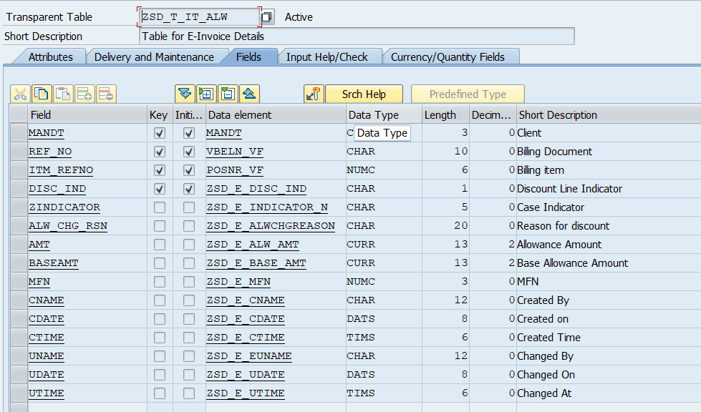

**Currency/Quantity Fields: -**

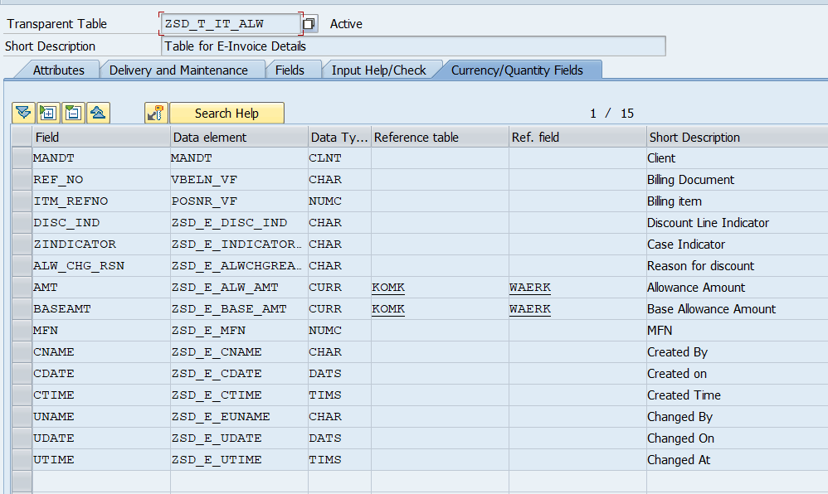

* **ZSD_T_XML_RES: -** XML Response and Download
  + **Package: - ZEINV_RAK**
  + **Delivery Class: - A**
  + **Data Browser/Table View: - Display/Maintenance Allowed with Restrictions**

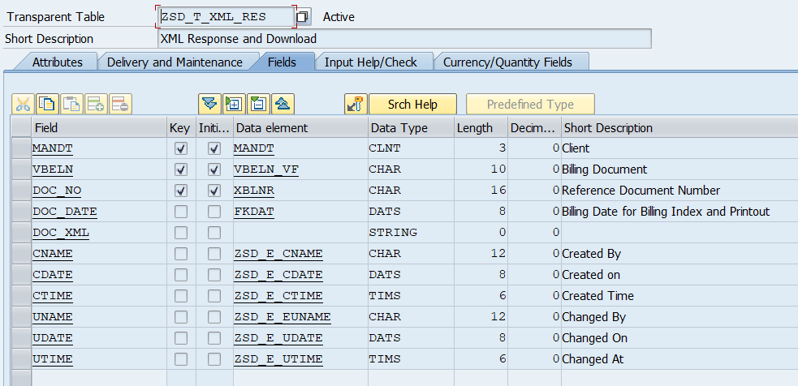

* **ZSD_T_ZINV_HT: -** Table for E-Invoice Details
  + **Package: - ZEINV_RAK**
  + **Delivery Class: - A**
  + **Data Browser/Table View: - Display/Maintenance Allowed with Restrictions**

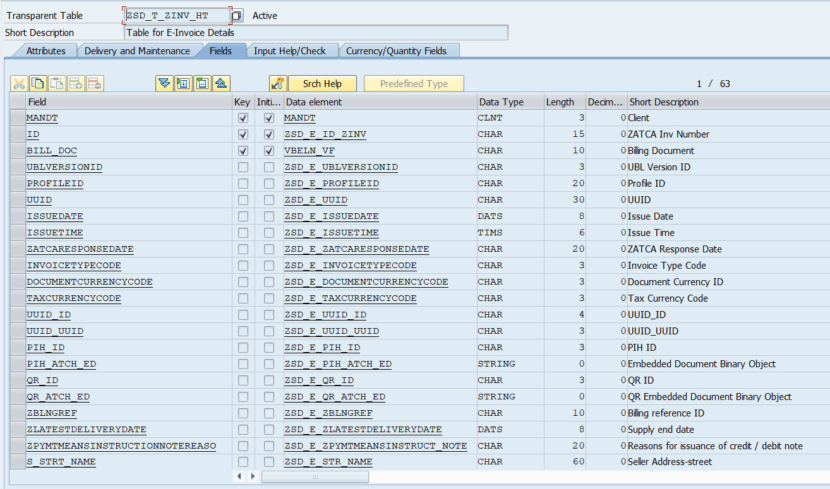

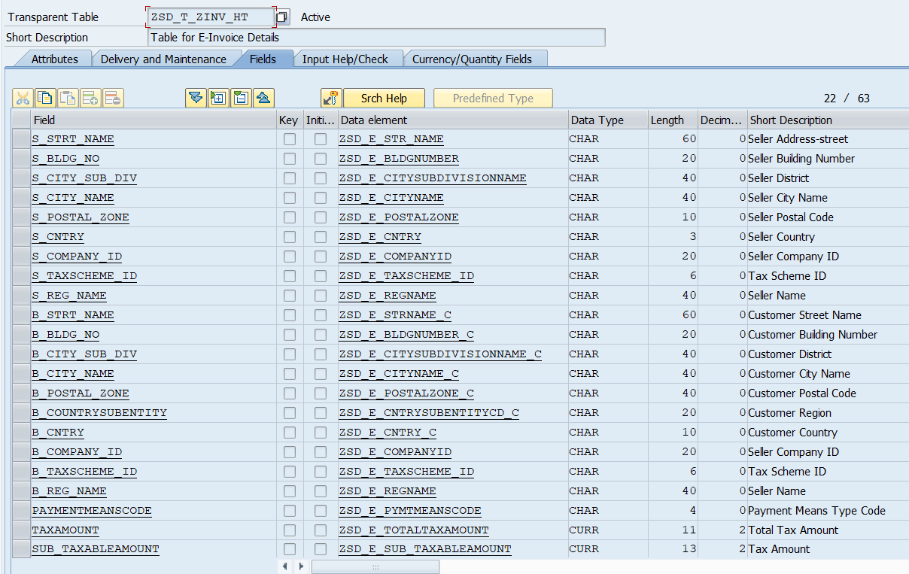

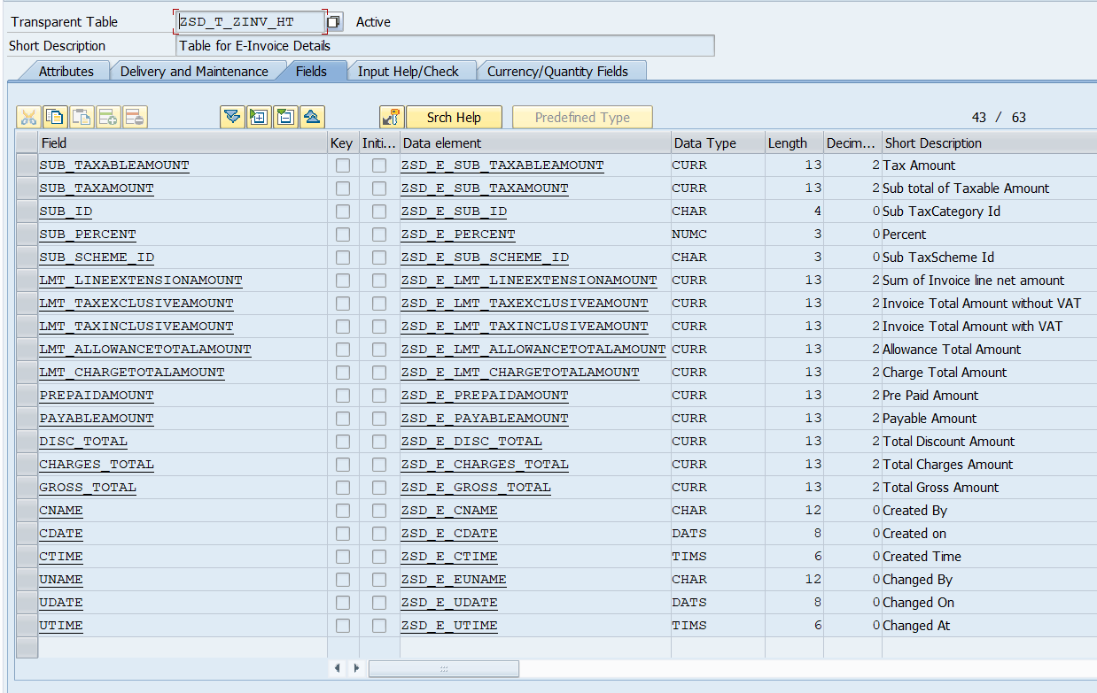

**Currency/Quantity Fields: -**

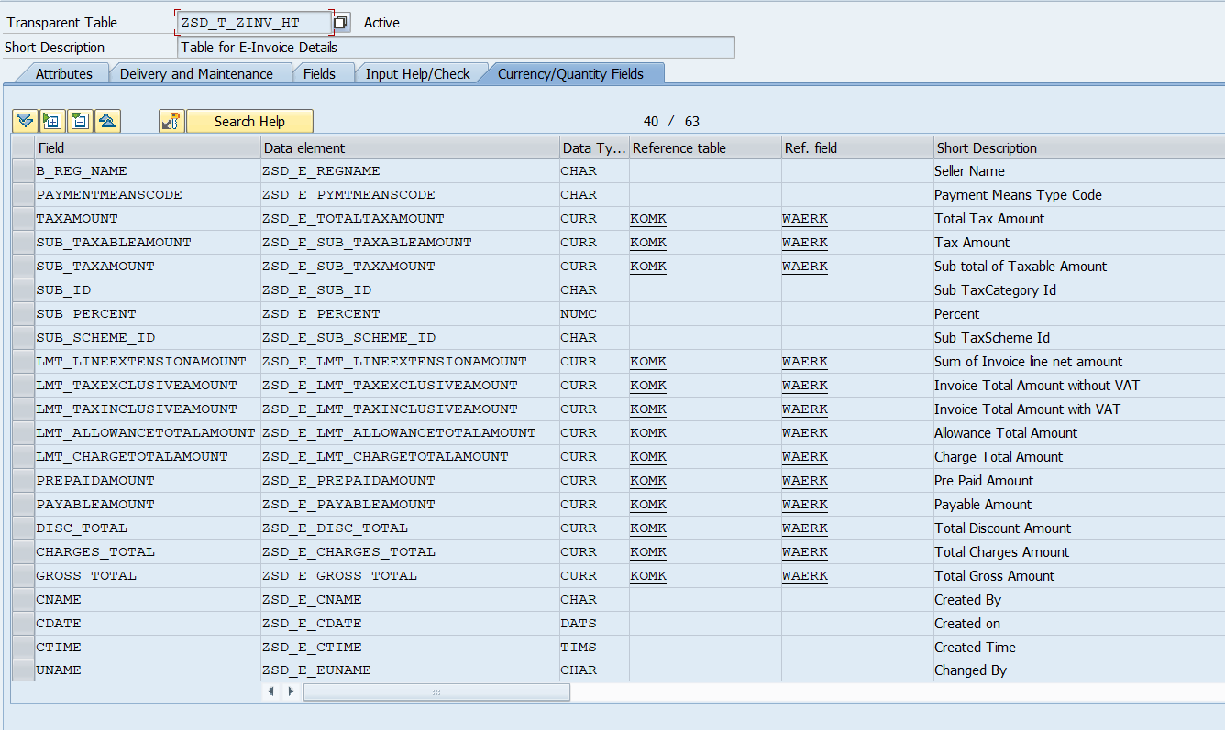

* **ZSD_T_ZINV_IT: -** Table for E-Invoice Details
  + **Package: - ZEINV_RAK**
  + **Delivery Class: - A**
  + **Data Browser/Table View: - Display/Maintenance Allowed with Restrictions**

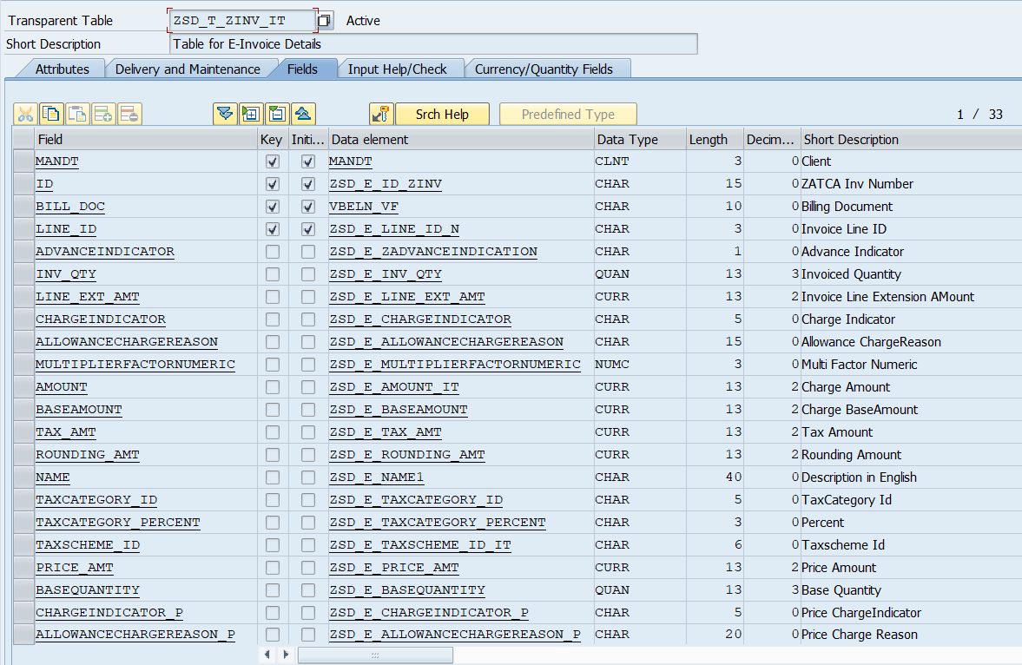

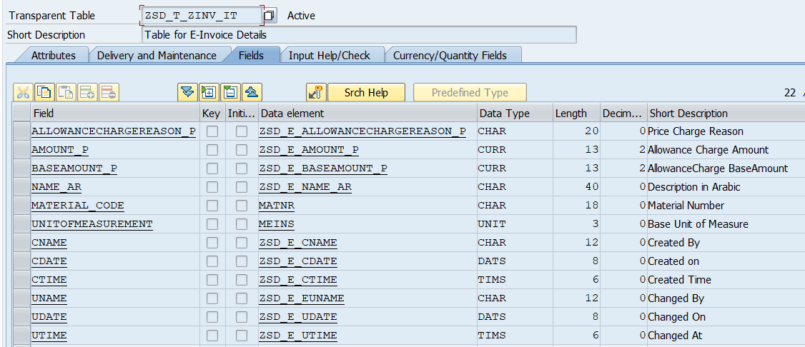

**Currency/Quantity Fields: -**

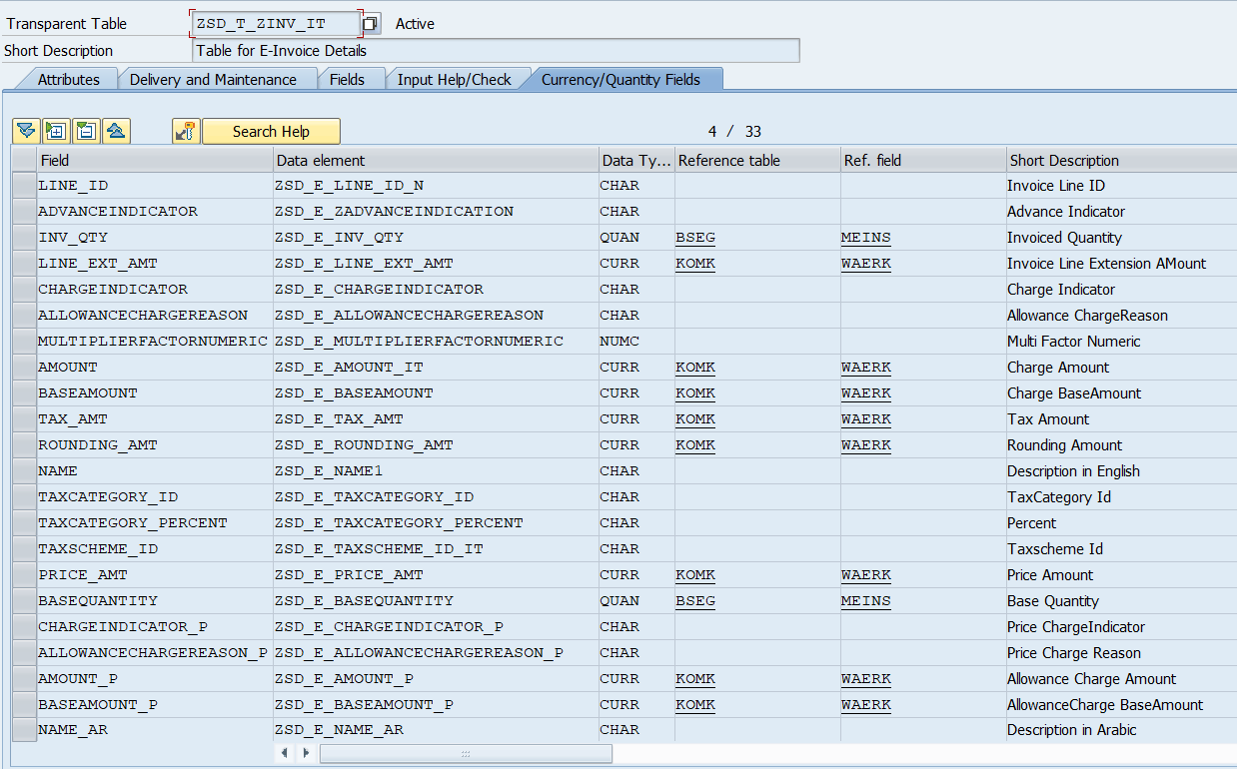

* **ZSD_T_ZINV_ALWC: -** Allowance Charges
  + **Package: - ZEINV_RAK**
  + **Delivery Class: - A**
  + **Data Browser/Table View: - Display/Maintenance Allowed with Restrictions**

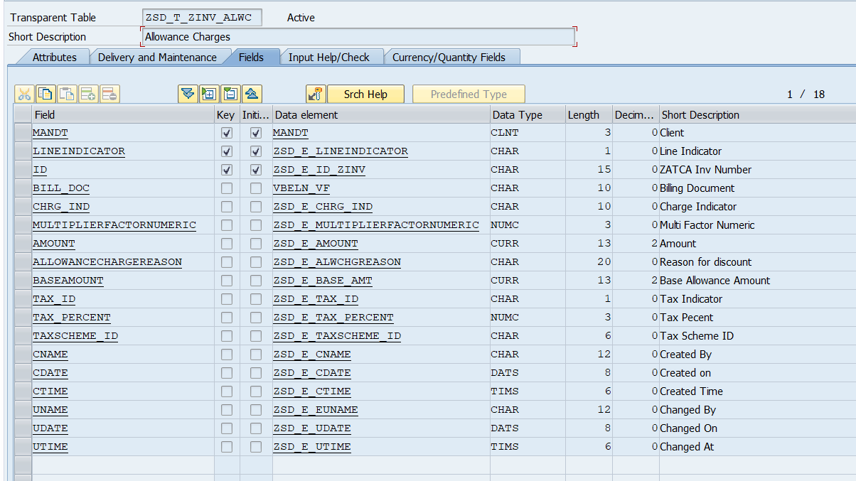

**Currency/Quantity Fields: -**

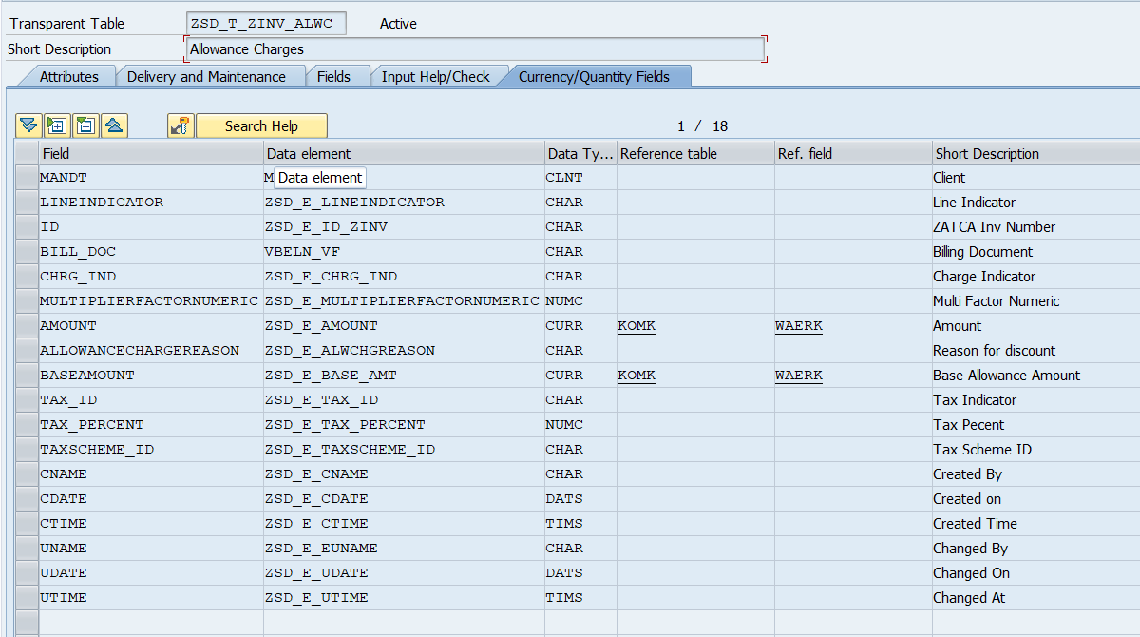

* **ZSD_T_CONDITIONS: -** Conditions Type
  + **Package: - ZEINV_RAK**
  + **Delivery Class: - A**
  + **Data Browser/Table View: - Display/Maintenance Allowed**

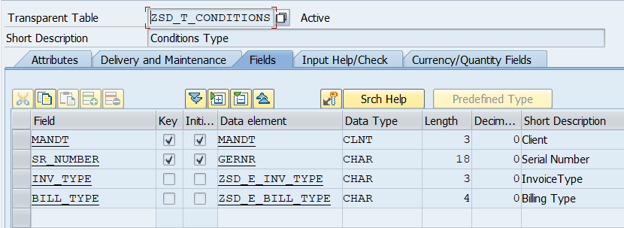

* **ZSD_T_EIN_LOG: -** eInvoice Generation Log
  + **Package: - ZEINV_RAK**
  + **Delivery Class: - A**
  + **Data Browser/Table View: - Display/Maintenance Allowed with Restrictions**

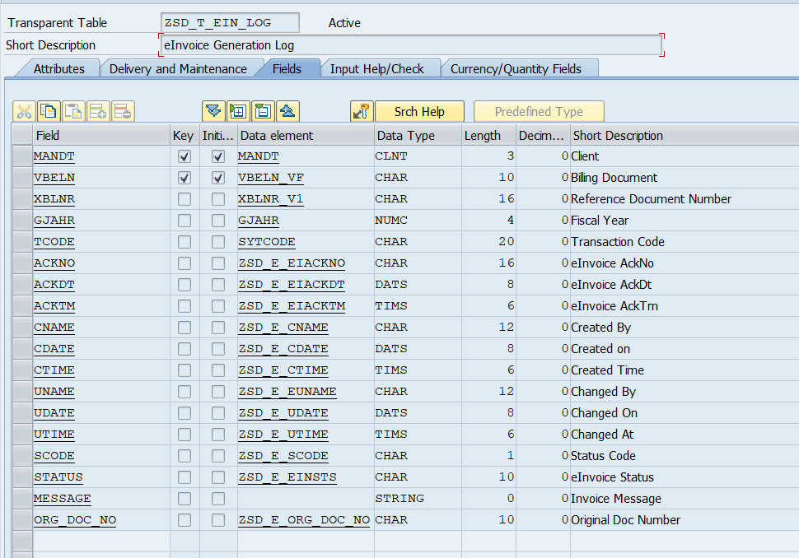

## Table Types

|  |  |  |
| --- | --- | --- |
| **Table Types Name** | **Line Type** | **Short Description** |
| ZSD_TT_ALLOWANCE_CHARGE | ZSD_S_ALLOWANCE_CHARGE | Allowance Charge |
| ZSD_TT_ALLOWANCHARGE | ZSD_S_ALLOWANCHARGE | Table Type for Allowance Charges |
| ZSD_TT_ALWCHG_STR_H | ZSD_S_EALWCHG_STR_H | Table Type for ALWCHG |
| ZSD_TT_EALWCHG_STR_I | ZSD_S_ALWCHG_STR_I | Alw CHG |
| ZSD_TT_EINVLINE | ZSD_S_EINVLINE | Table Type for INVLINE |
| ZSD_TT_INVOICELINE | ZSD_S_INVOICELINE | Invoice Line |
| ZSD_TT_KNA1 | KNA1 | Table Type for Kna1 |
| ZSD_TT_MAKT | MAKT | Table Type For MAKT |
| ZSD_TT_T001Z | T001Z | Table Type for T001Z |
| ZSD_TT_T005U | T005U | Table Type for T005U |
| ZSD_TT_T005Z | T005Z | Table type for T005Z |
| ZSD_TT_TAXSUBTOTAL | ZSD_S_TAXSUBTOTAL | Tax Subtotal |

## Structure details

|  |  |
| --- | --- |
| **Structure Name** | **Short Description** |
| ZSD_S_ACCOUNTINGCUSTOMERPARTY | Structure for Customer Party Details |
| ZSD_S_ACCOUNTINGSUPLIERPARTY | Structure for Seller Party Details |
| ZSD_S_ADD_DOCUMENT_REFERENC | Additional Document Ref |
| ZSD_S_ALLOWANCECHARGE | Allowance Charge |
| ZSD_S_ALLOWANCE_CHARGE | ALLOWANCE CHARGE |
| ZSD_S_ALWCHG_STR_I | AlwChg |
| ZSD_S_ATTACHMENT | Attachment |
| ZSD_S_CLASSIFIEDTAXCATEGORY | Classified Tax Category |
| ZSD_S_CUSTOMERINV | Structure for Customer Invoice Print |
| ZSD_S_CUSTOMER_DETAILS | Customer Details |
| ZSD_S_CUSTOMER_PARTY | Structure for Customer Party |
| ZSD_S_CUSTOMER_PARTYTAXSCHEME | Customer Party Scheme |
| ZSD_S_CUSTOMER_POSTALADDRESS | Customer Poatal address |
| ZSD_S_CUSTOMER_TAXSCEME | Structure for Customer Tax Scheme |
| ZSD_S_CUSTOME_PARTYLEGALENTITY | Customer Party Legal Entity |
| ZSD_S_EACTNGCUSTOMERPARTY | For Customer Party |
| ZSD_S_EACTNGSUPLPARTY | For Supl Party |
| ZSD_S_EALWCHG_STR | ALWCHG_STR |
| ZSD_S_EALWCHG_STR_H | ALWCHG_STR |
| ZSD_S_ECLASTAXCAT | For Class Text Cat |
| ZSD_S_EEINV | eInvoicing |
| ZSD_S_EINVLINE | For InvLine |
| ZSD_S_EINV_ALWCHG | Discount Structure |
| ZSD_S_EINV_LINE | Invoice Details |
| ZSD_S_EINV_LINEITEM | Invoice Line Item |
| ZSD_S_EIN_KSA_RES | Deep Structure for JSON Response |
| ZSD_S_EITEM | For Item Table |
| ZSD_S_ELEGALMONETARYTOTAL | Legal Mandatory Total |
| ZSD_S_EPARTYLEGALENTITY | Seller Details for Party Legel Entity |
| ZSD_S_EPARTYTAXSCHEME | Party Tax Scheme |
| ZSD_S_EPARTY_CUS | Customer Party Details |
| ZSD_S_EPARTY_SUP | Supplier Party Detail |
| ZSD_S_EPOSTALADDRESS_CUS | Postal Address For Cus Party |
| ZSD_S_EPOSTALADDRESS_SUP | Postal Address For Sup Party |
| ZSD_S_EPRICE | For Price |
| ZSD_S_EPRICE_T | Price Structure |
| ZSD_S_ETAXCAT | Tax Cat Structure |
| ZSD_S_ETAXTOTAL | For Tax Total |
| ZSD_S_ETOKEN_REQEST | Token Request |
| ZSD_S_INVOICE | Structure for Invoice |
| ZSD_S_INVOICELINE | Invoice Line Details |
| ZSD_S_ITEM_T | Item Details |
| ZSD_S_ORDER_REFERENCE | Order Reference |
| ZSD_S_PAYMENTMEANS | Payment Means Code |
| ZSD_S_PIH | PIH |
| ZSD_S_PRICE_T | Price Structure |
| ZSD_S_QR | QR |
| ZSD_S_QR_ATTACHMENT | QR Attachment |
| ZSD_S_SELLER_COUNTRY | Seller Country Structure |
| ZSD_S_SELLER_DETAILS | Seller Details |
| ZSD_S_SELLER_TAXSCEME | Structure for Seller Tax Scheme |
| ZSD_S_SUPPLIER_PARTY | Structure for Supplier Party |
| ZSD_S_SUPPLIER_PARTYTAXSCHEME | Supplier Party Scheme |
| ZSD_S_SUPPLIER_POSTALADDRESS | Seller Postal address |
| ZSD_S_SUPPLIE_PARTYLEGALENTITY | Supplier Party Legal Entity |
| ZSD_S_TAXAMOUNT | Tax Amount |
| ZSD_S_TAXCATEGORY | Tax Category |
| ZSD_S_TAXSCHEME | Tax Scheme |
| ZSD_S_TAXSUBTOTAL | Tax Subtotal |
| ZSD_S_TAXTOTAL_LINE | TaxTotal Line |
| ZSD_S_TAX_CATEGORY | Tax Category |
| ZSD_S_TAX_SCHEME | TAX Scheme |
| ZSD_S_TEMP | Deep Structure for testing |
| ZSD_S_TTAXTOTAL | Tax Total Structure |
| ZSD_S_UUID | UUID |

* **ZSD_S_ACCOUNTINGCUSTOMERPARTY: -** Structure for Customer Party Details

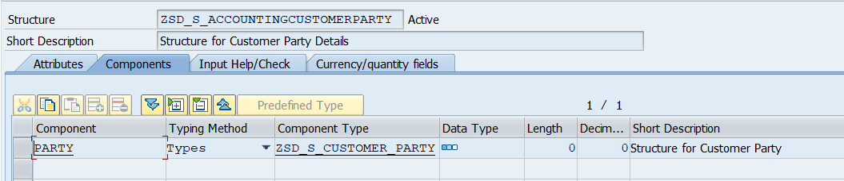

* **ZSD_S_ACCOUNTINGSUPLIERPARTY: -** Structure for Seller Party Details

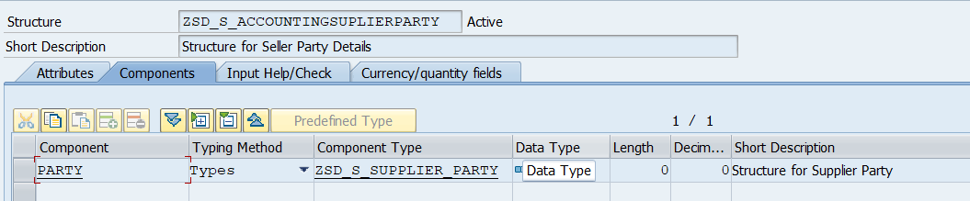

* **ZSD_S_ADD_DOCUMENT_REFERENC: -** Additional Document Ref

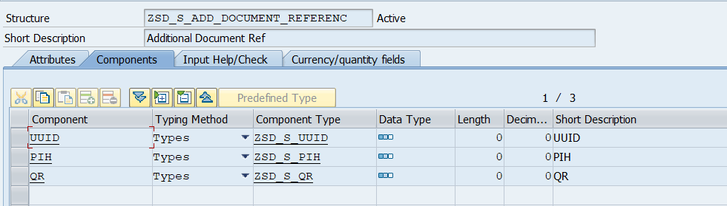

* **ZSD_S_ALLOWANCECHARGE: -** Allowance Charge

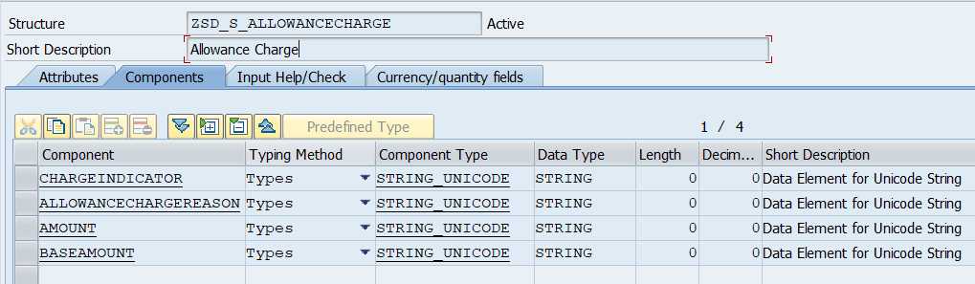

* **ZSD_S_ALLOWANCE_CHARGE: -** ALLOWANCE CHARGE

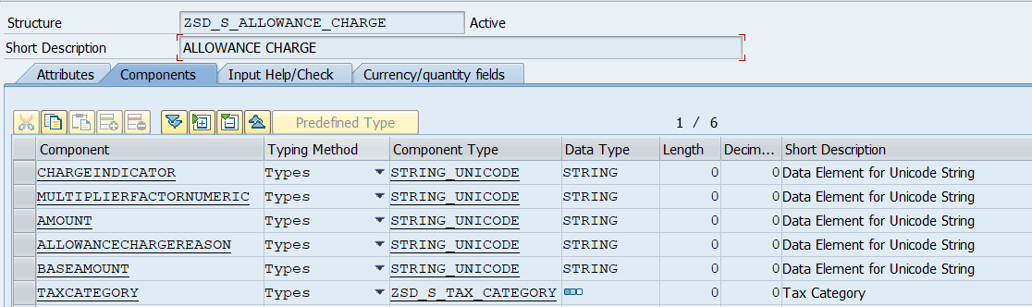

* **ZSD_S_ALWCHG_STR_I: -** AlwChg

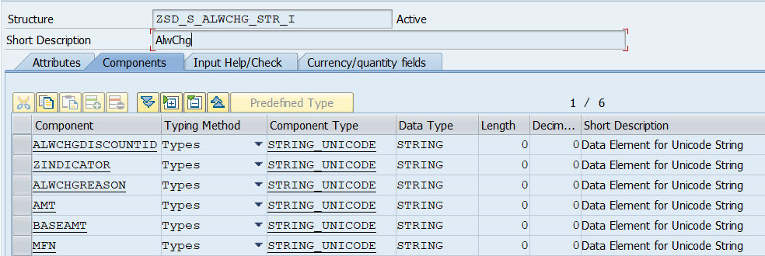

* **ZSD_S_ATTACHMENT: -** Attachment

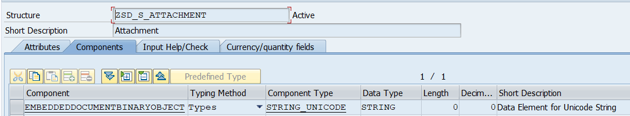

* **ZSD_S_CLASSIFIEDTAXCATEGORY: -** Classified Tax Category

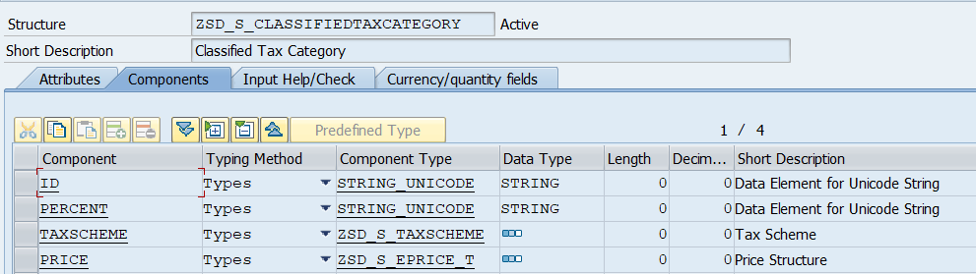

* **ZSD_S_CUSTOMERINV: -** Structure for Customer Invoice Print

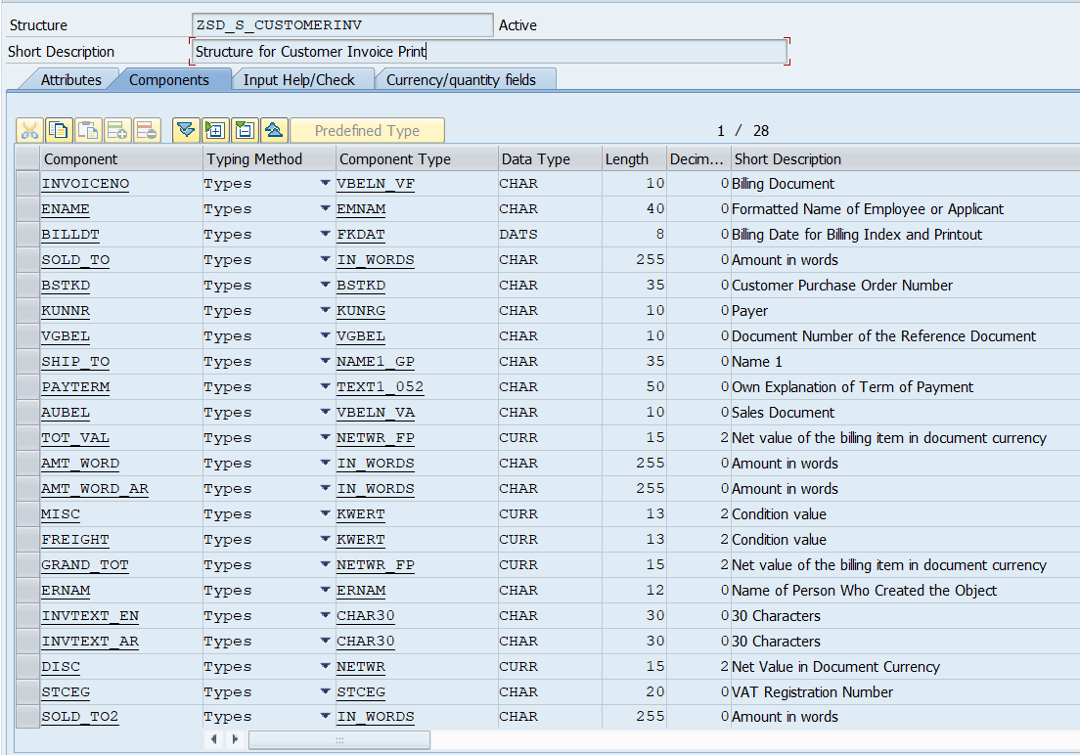

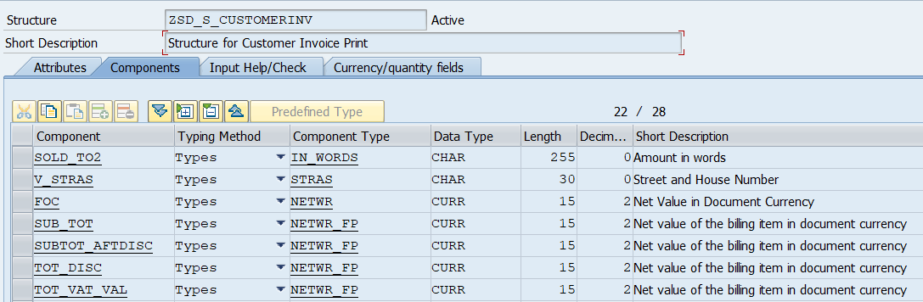

**Currency/Quantity Fields: -**

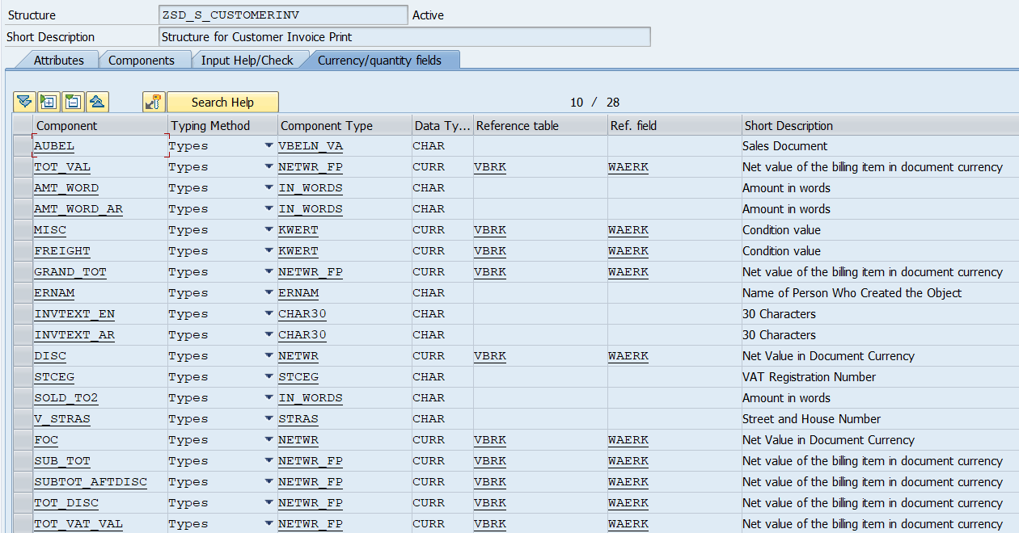

* **ZSD_S_CUSTOMER_DETAILS: -** Customer Details

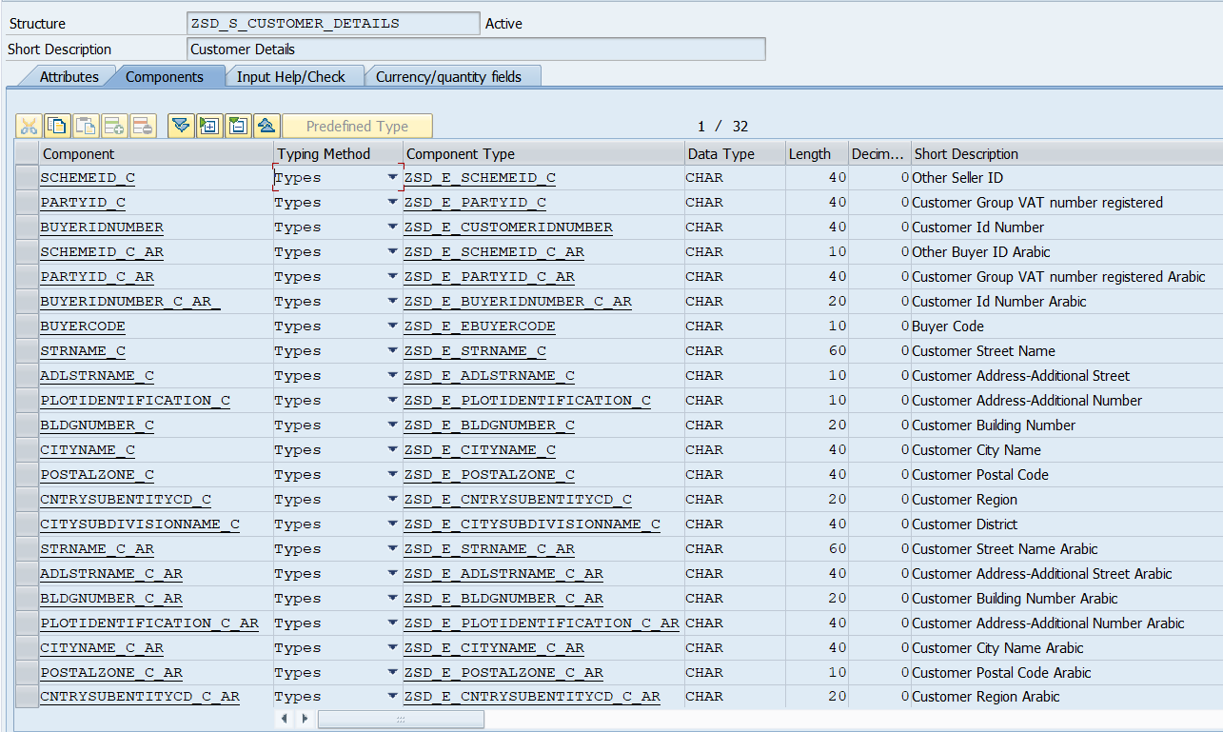

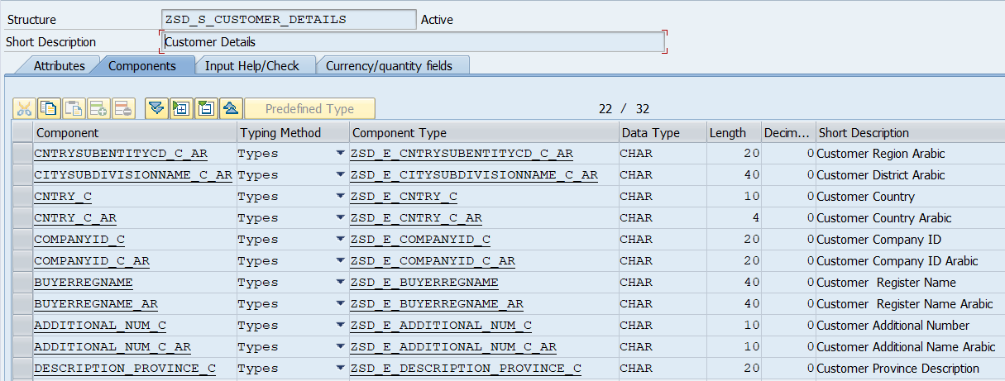

* **ZSD_S_CUSTOMER_PARTY: -** Structure for Customer Party

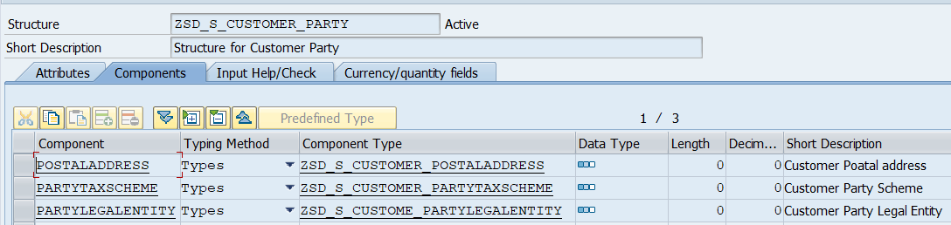

* **ZSD_S_CUSTOMER_PARTYTAXSCHEME: -** Customer Party Scheme

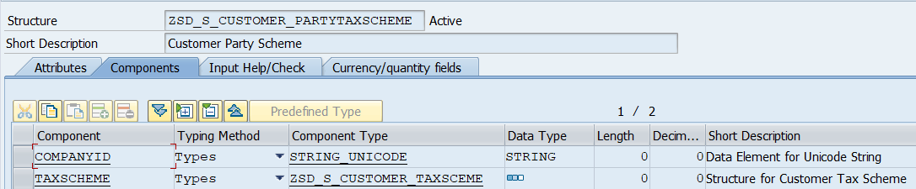

* **ZSD_S_CUSTOMER_POSTALADDRESS: -** Customer Postal address

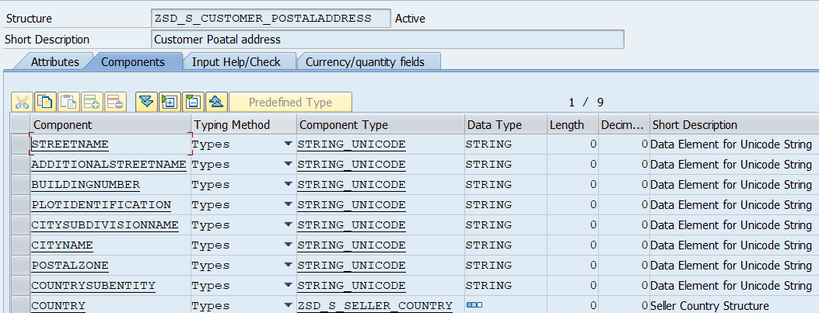

* **ZSD_S_CUSTOMER_TAXSCEME: -** Structure for Customer Tax Scheme

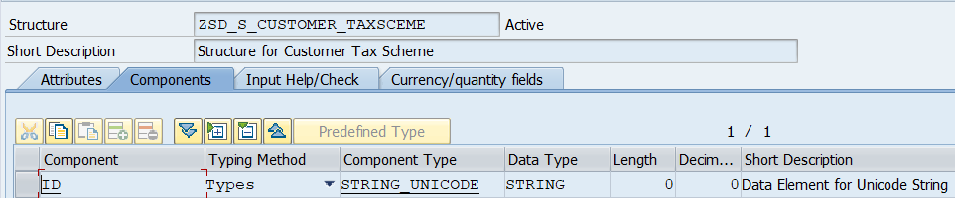

* **ZSD_S_CUSTOME_PARTYLEGALENTITY: -** Customer Party Legal Entity

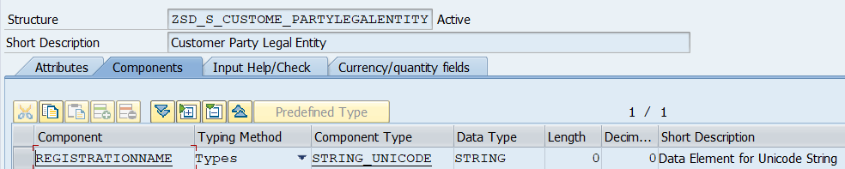

* **ZSD_S_EACTNGCUSTOMERPARTY: -** For Customer Party

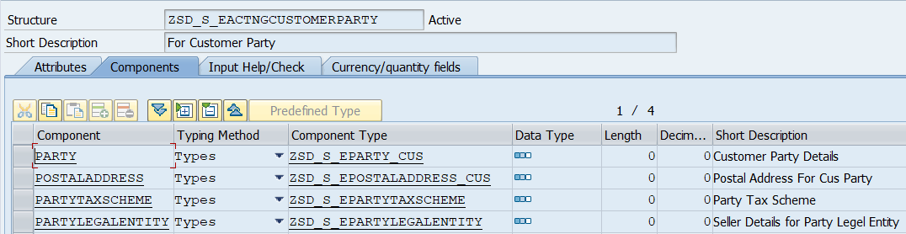

* **ZSD_S_EACTNGSUPLPARTY: -** For Supl Party

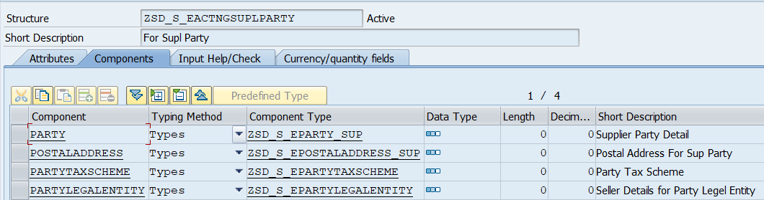

* **ZSD_S_EALWCHG_STR: -** ALWCHG_STR

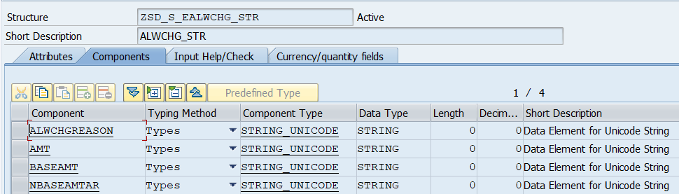

* **ZSD_S_EALWCHG_STR_H: -** ALWCHG_STR

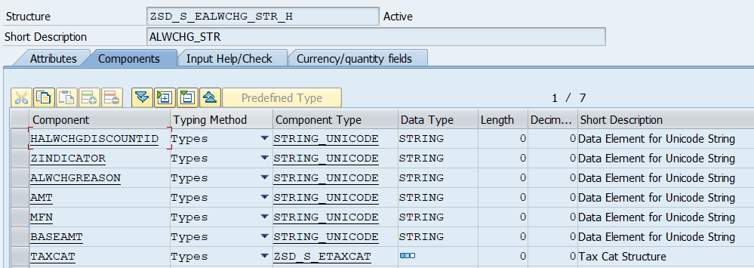

* **ZSD_S_ECLASTAXCAT: -** For Class Text Cat

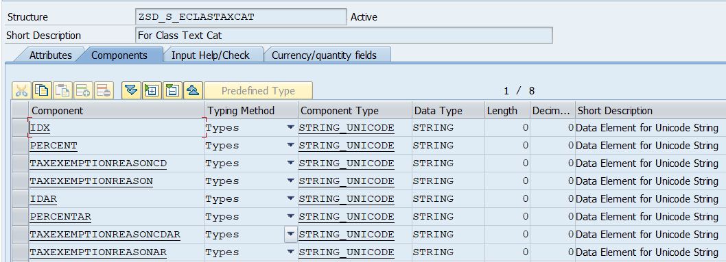

* **ZSD_S_EEINV: -** eInvoicing

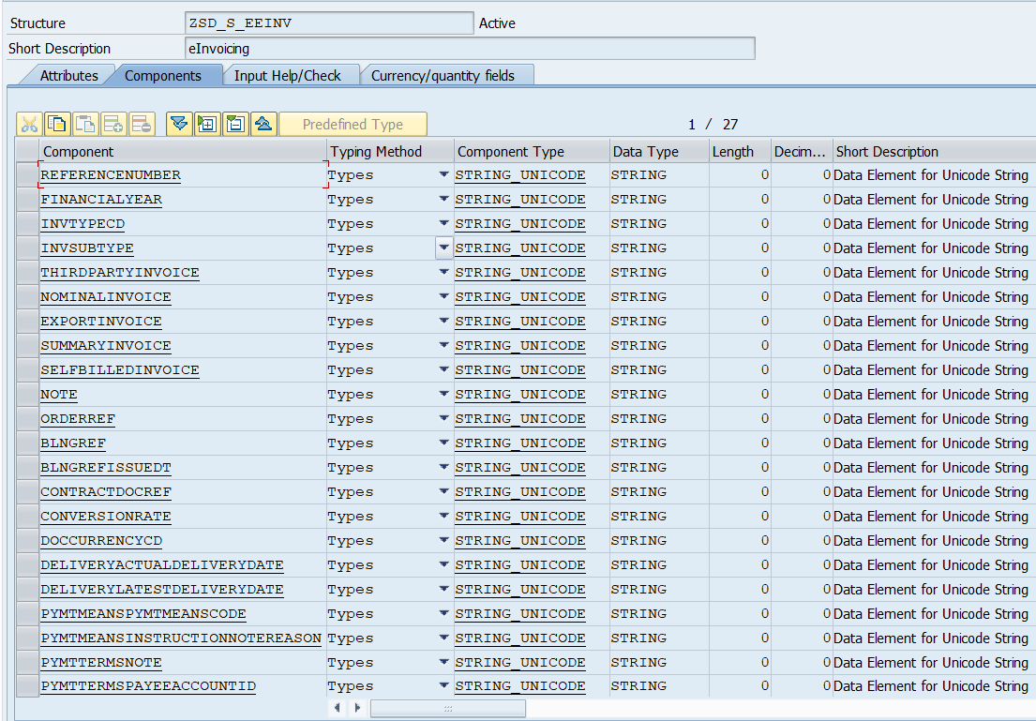

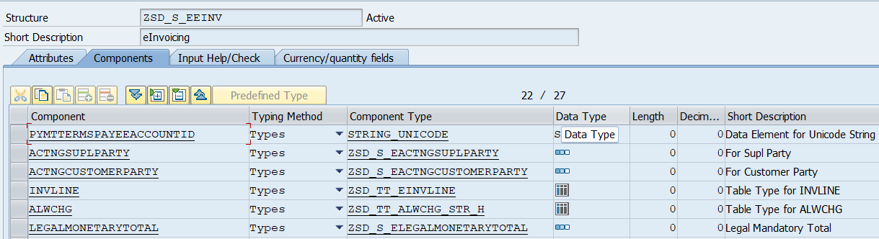

* **ZSD_S_EINVLINE: -** For InvLine

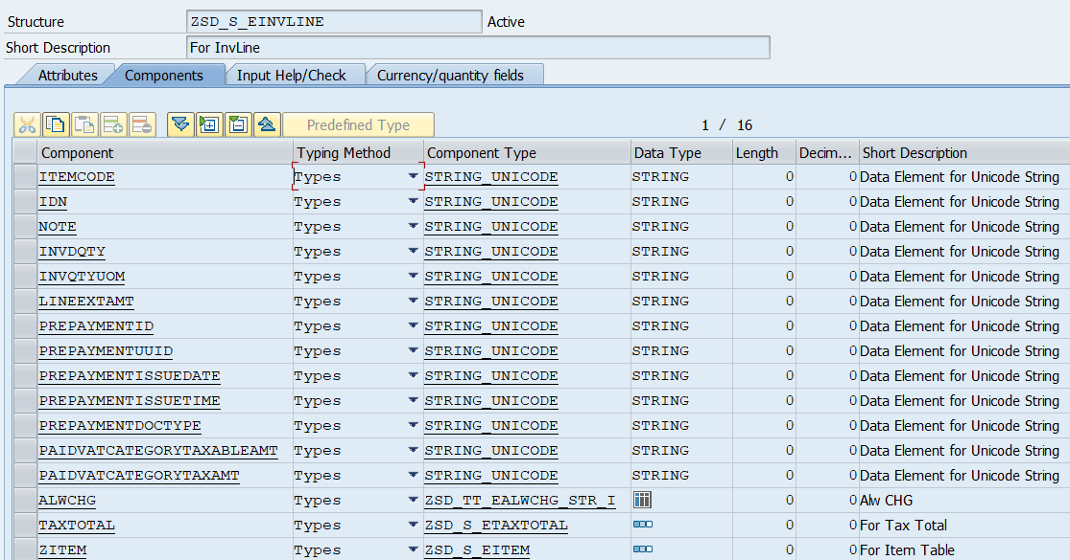

* **ZSD_S_EINV_ALWCHG: -** Discount Structure

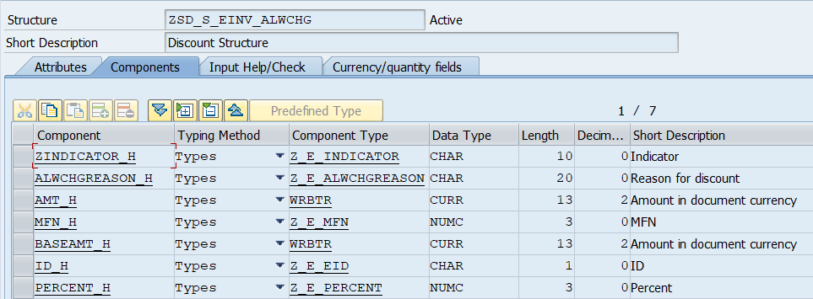

**Currency/Quantity Fields: -**

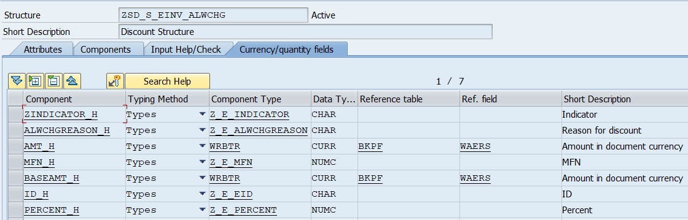

* **ZSD_S_EINV_LINE: -** Invoice Details

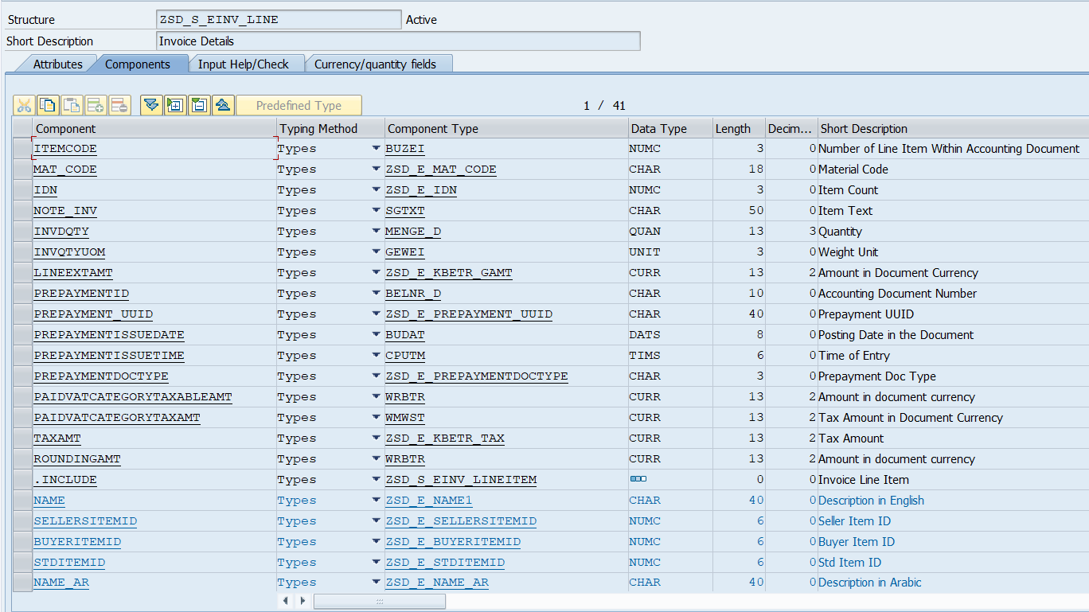

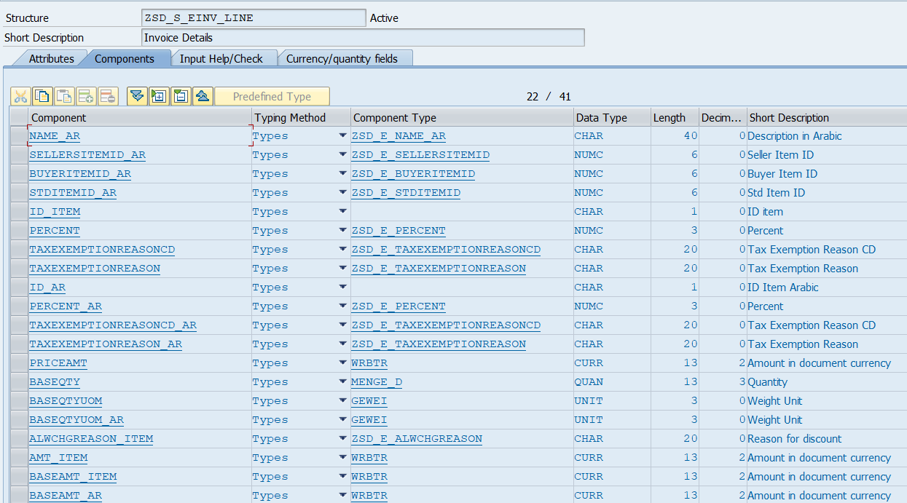

**Currency/Quantity Fields: -**

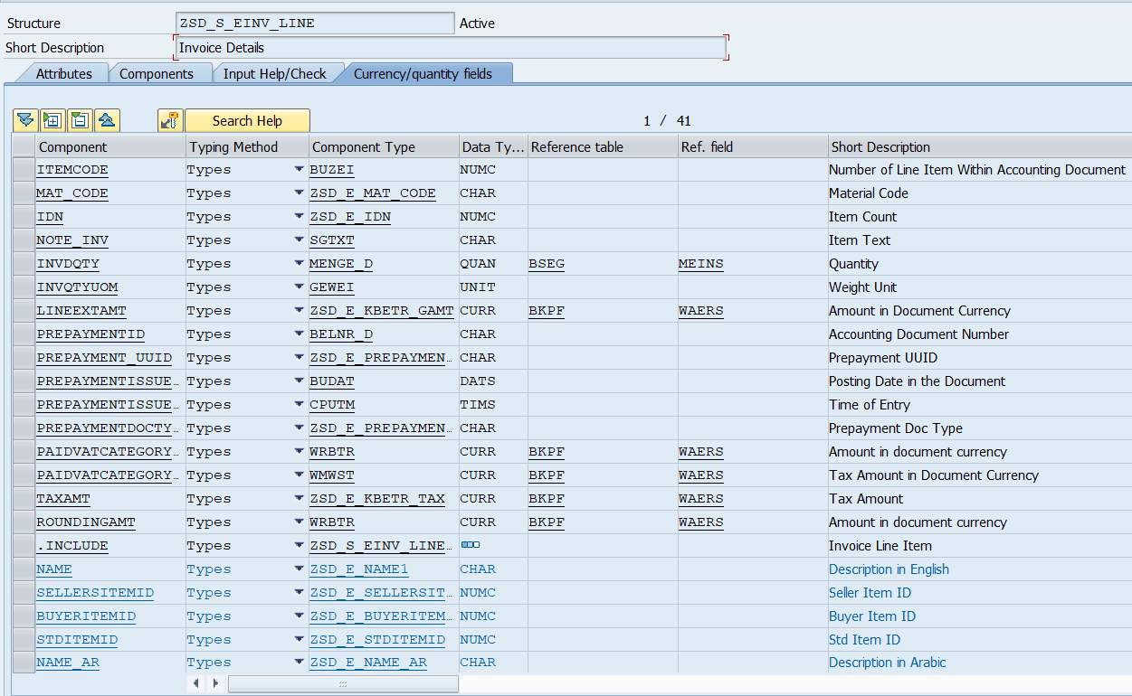

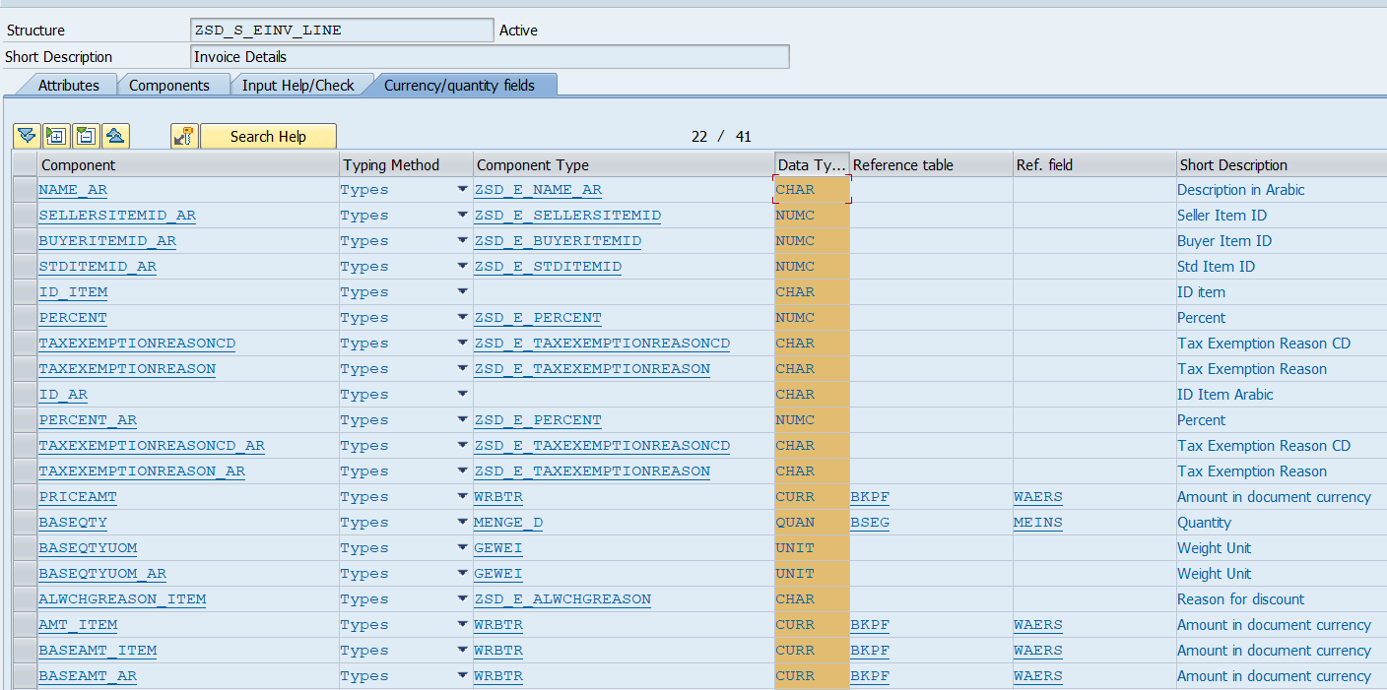

* **ZSD_S_EINV_LINEITEM: -** Invoice Line Item

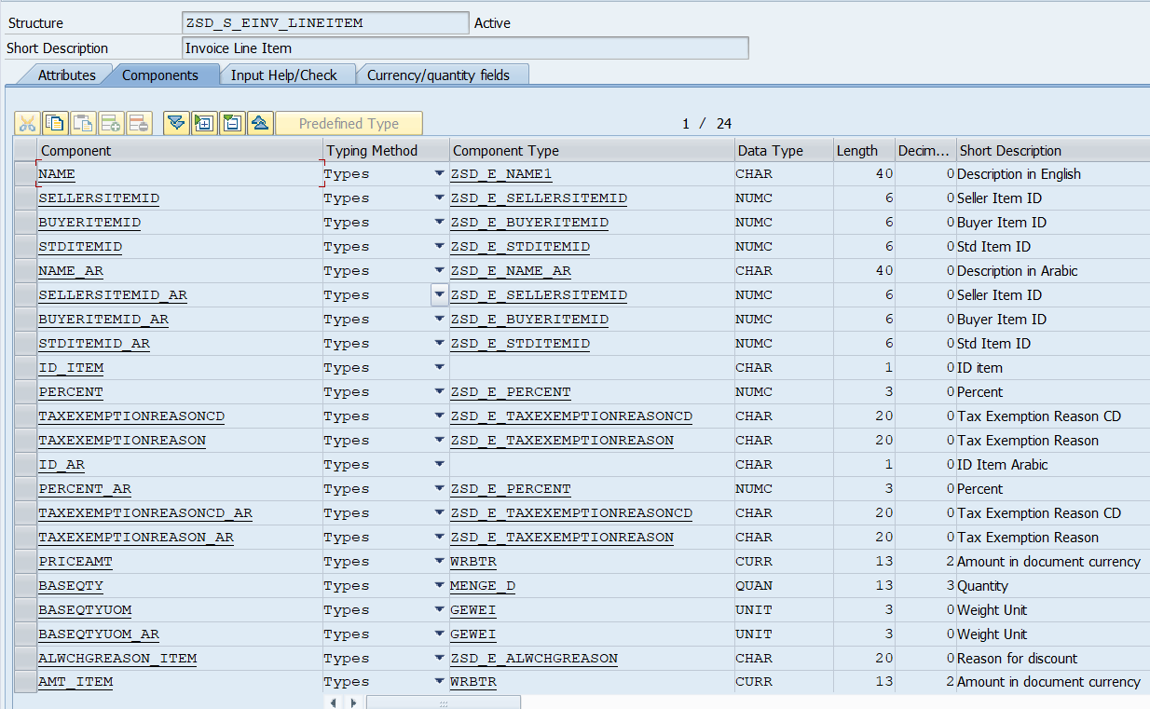

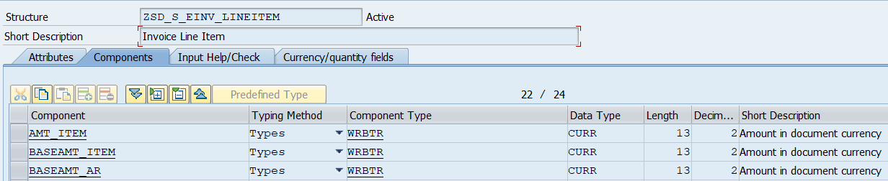

**Currency/Quantity Fields: -**

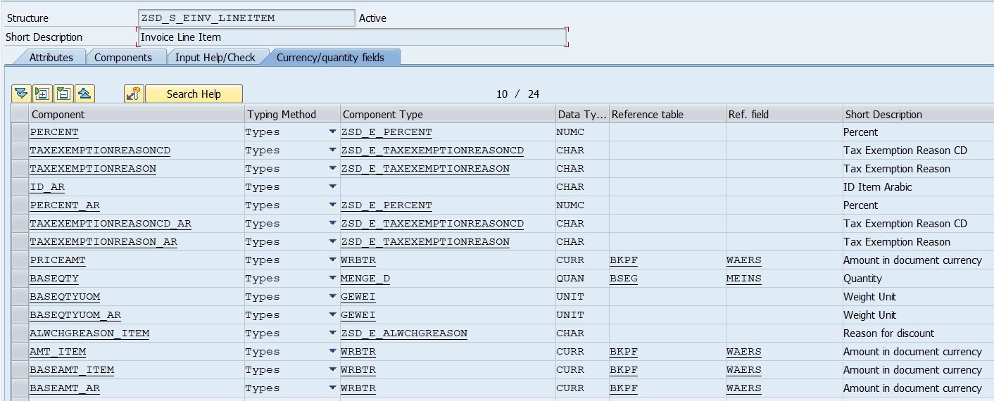

* **ZSD_S_EIN_KSA_RES: -** Deep Structure for JSON Response

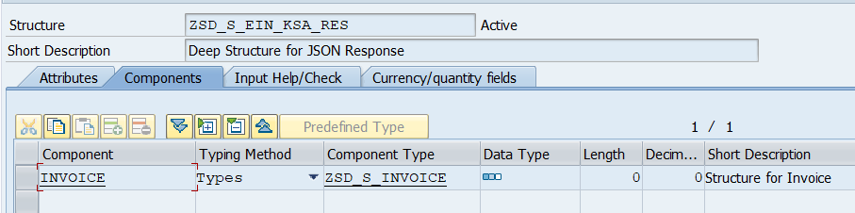

* **ZSD_S_EITEM: -** For Item Table

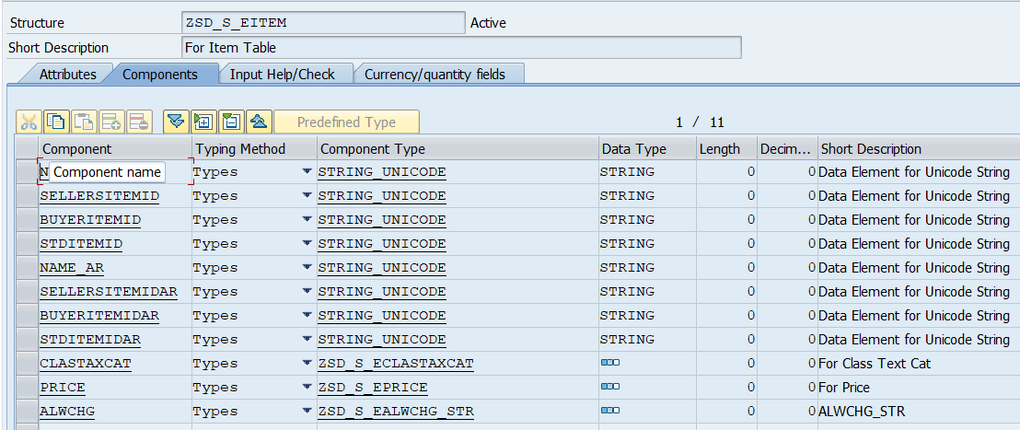

* **ZSD_S_ELEGALMONETARYTOTAL: -** Legal Mandatory Total

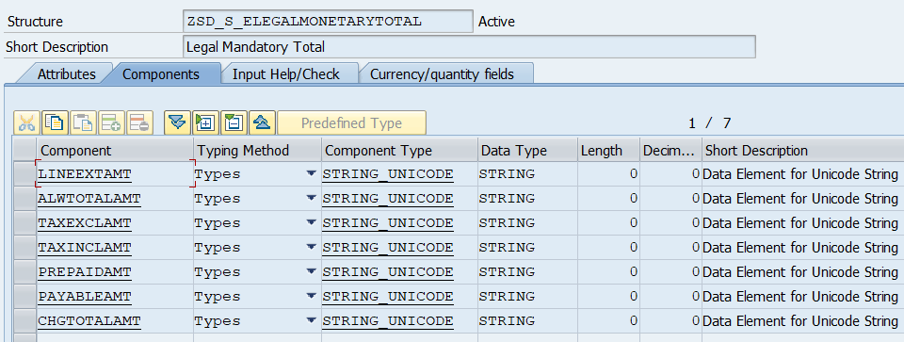

* **ZSD_S_EPARTYLEGALENTITY: -** Seller Details for Party Legel Entity

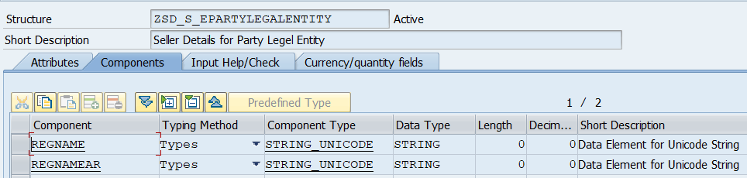

* **ZSD_S_EPARTYTAXSCHEME: -** Party Tax Scheme

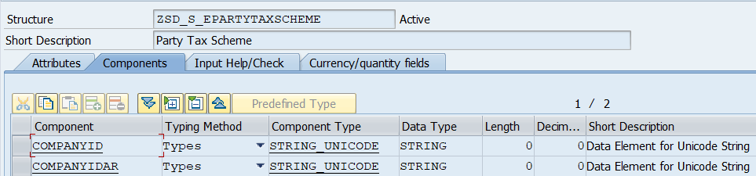

* **ZSD_S_EPARTY_CUS: -** Customer Party Details

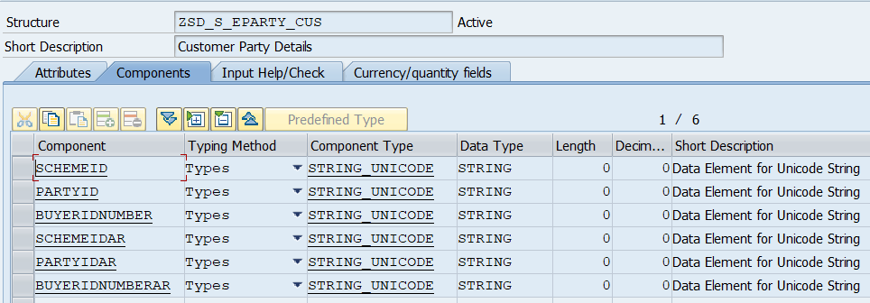

* **ZSD_S_EPARTY_SUP: -** Supplier Party Detail

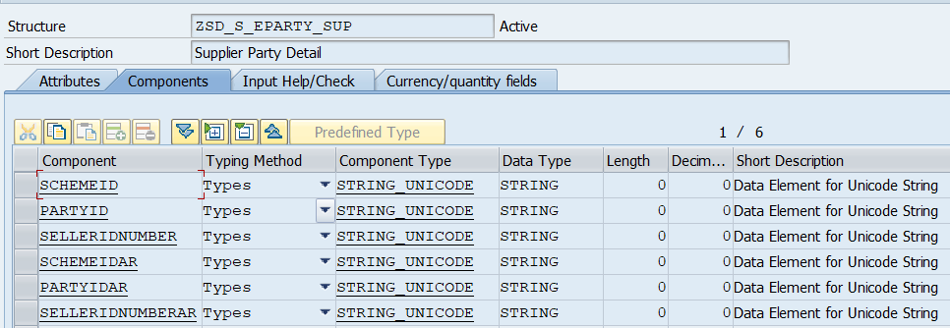

* **ZSD_S_EPOSTALADDRESS_CUS: -** Postal Address For Cus Party

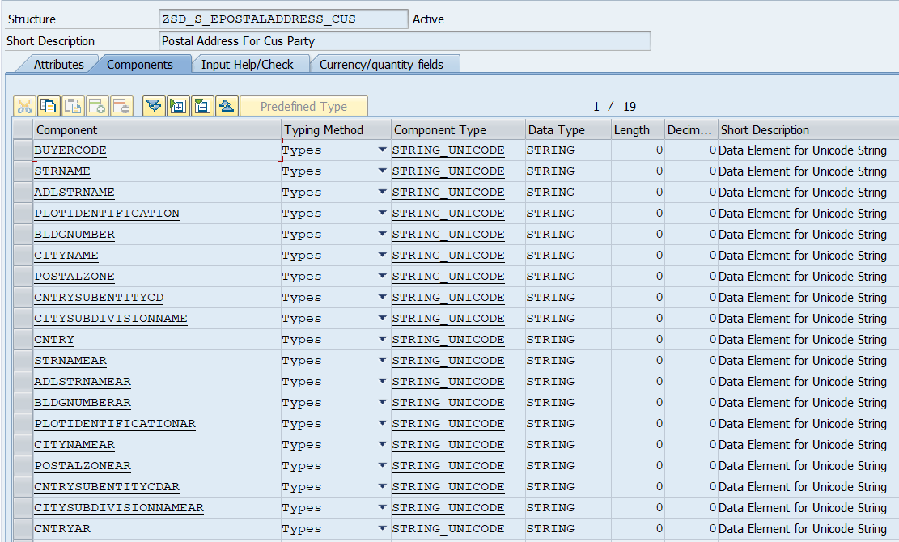

* **ZSD_S_EPOSTALADDRESS_SUP: -** Postal Address For Sup Party

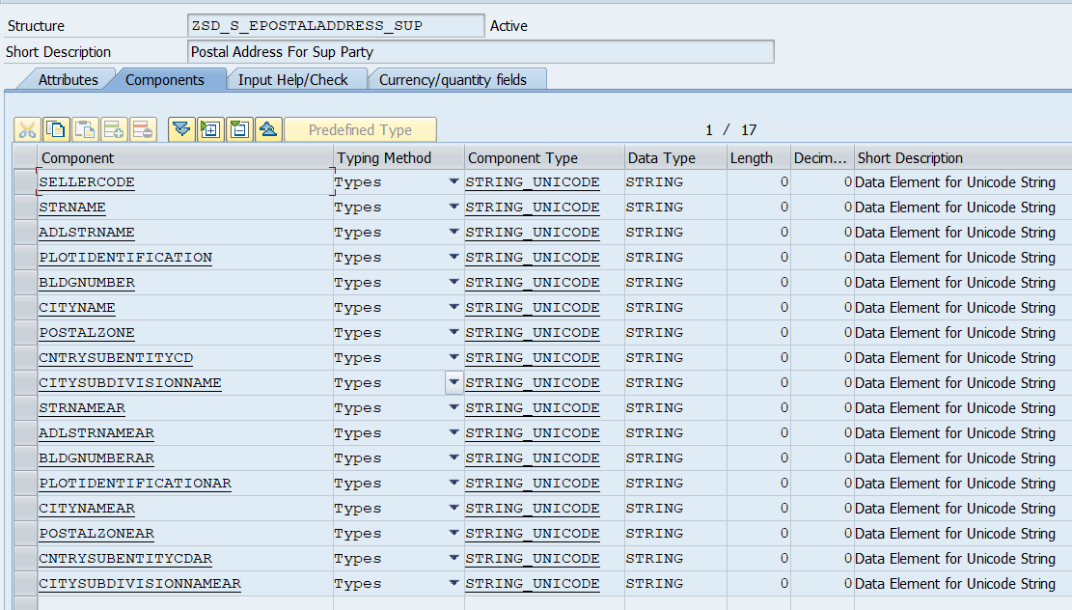

* **ZSD_S_EPRICE: -** For Price

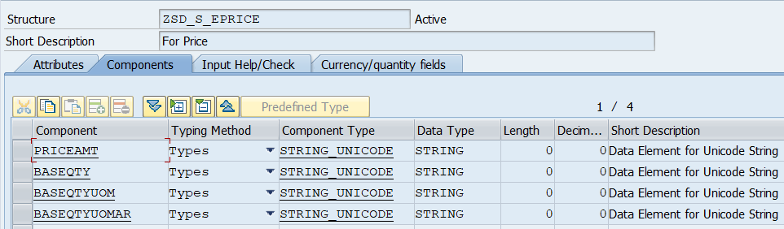

* **ZSD_S_EPRICE_T: -** Price Structure

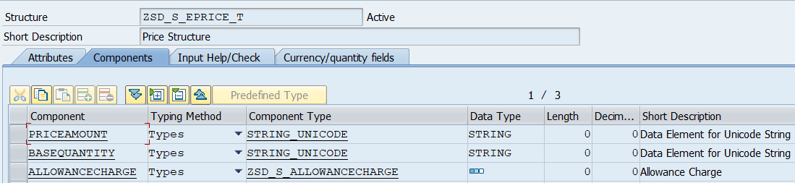

* **ZSD_S_ETAXCAT: -** Tax Cat Structure

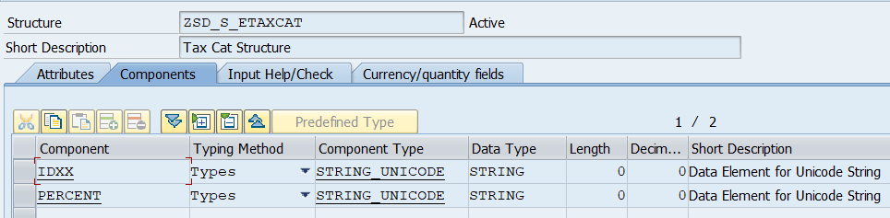

* **ZSD_S_ETAXTOTAL: -** For Tax Total

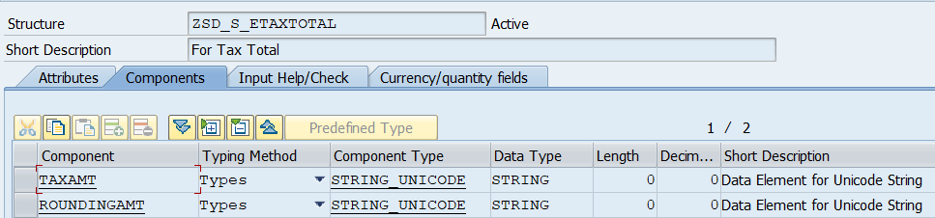

* **ZSD_S_ETOKEN_REQEST: -** Token Request

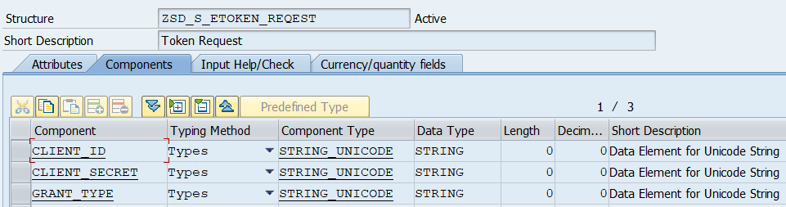

* **ZSD_S_INVOICE: -** Structure for Invoice

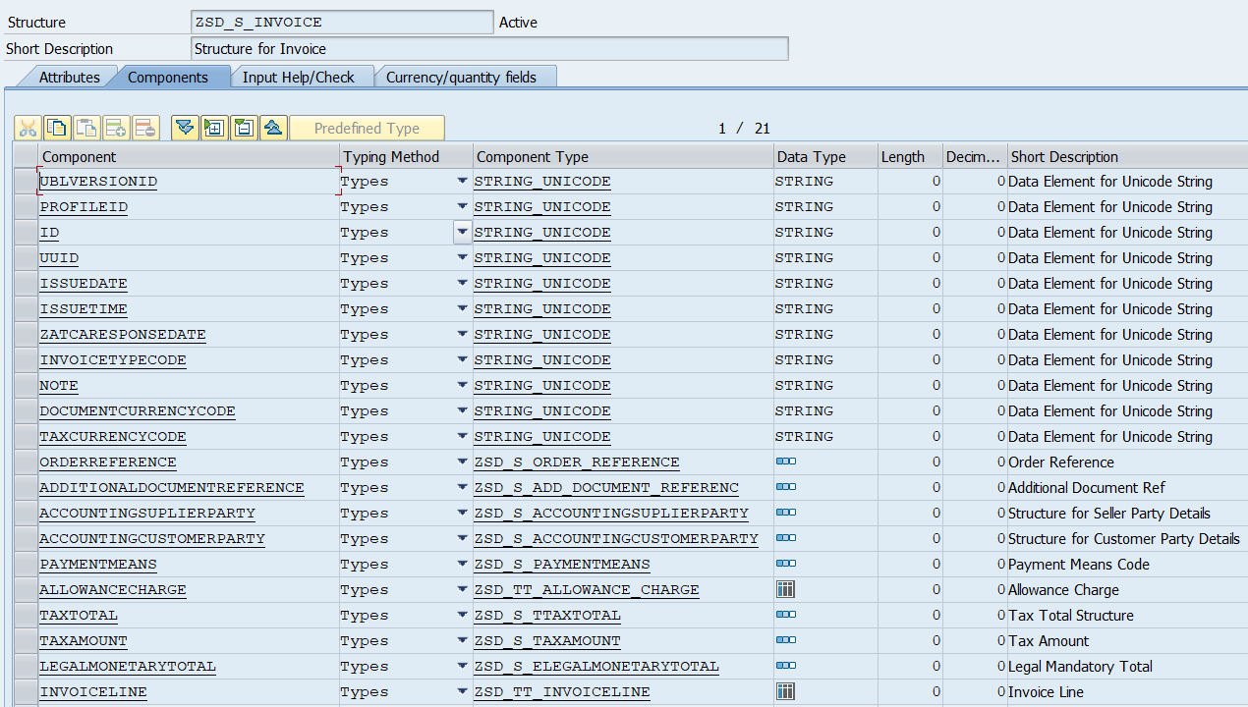

* **ZSD_S_INVOICELINE: -** Invoice Line Details

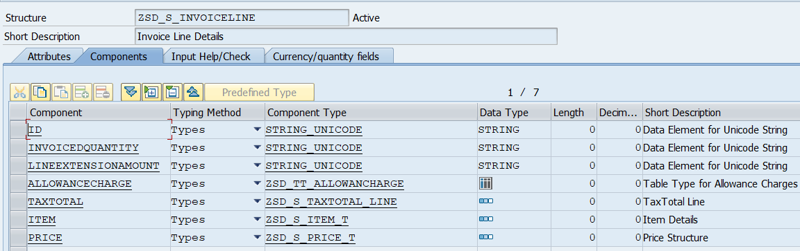

* **ZSD_S_ITEM_T: -** Item Details

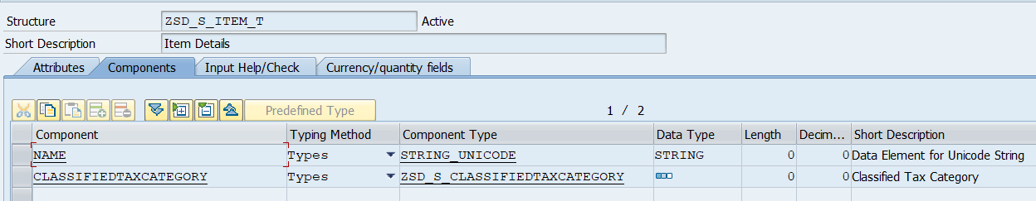

* **ZSD_S_ALLOWANCECHARGE: -** Allowance Charge

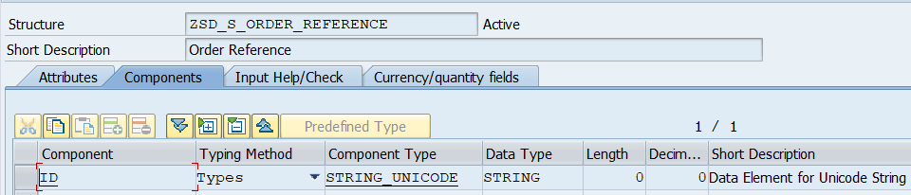

* **ZSD_S_PAYMENTMEANS: -** Payment Means Code

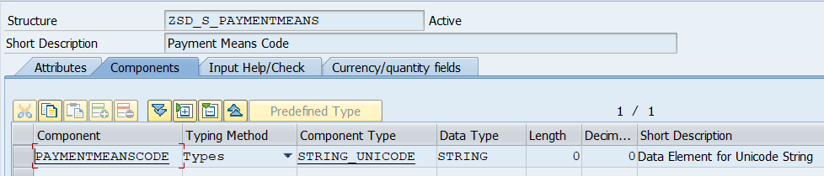

* **ZSD_S_PIH: -** PIH

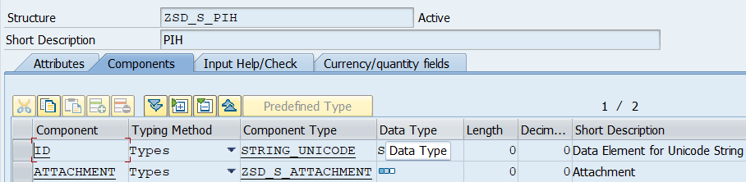

* **ZSD_S_PRICE_T: -** Price Structure

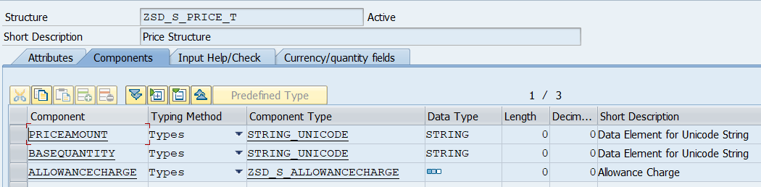

* **ZSD_S_QR: -** QR

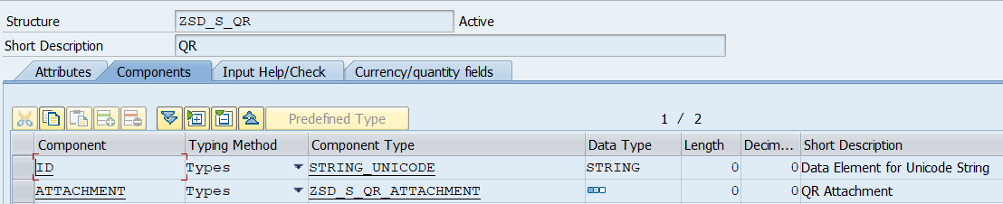

* **ZSD_S_QR_ATTACHMENT: -** QR Attachment

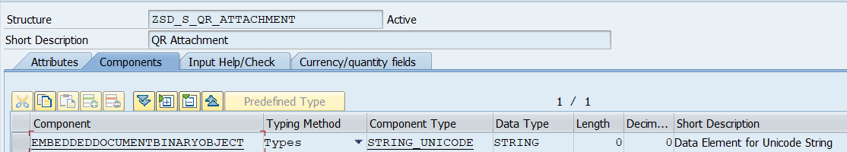

* **ZSD_S_SELLER_COUNTRY: -** Seller Country Structure

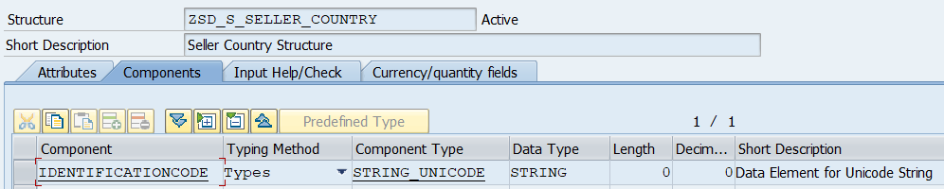

* **ZSD_S_ALLOWANCECHARGE: -** Allowance

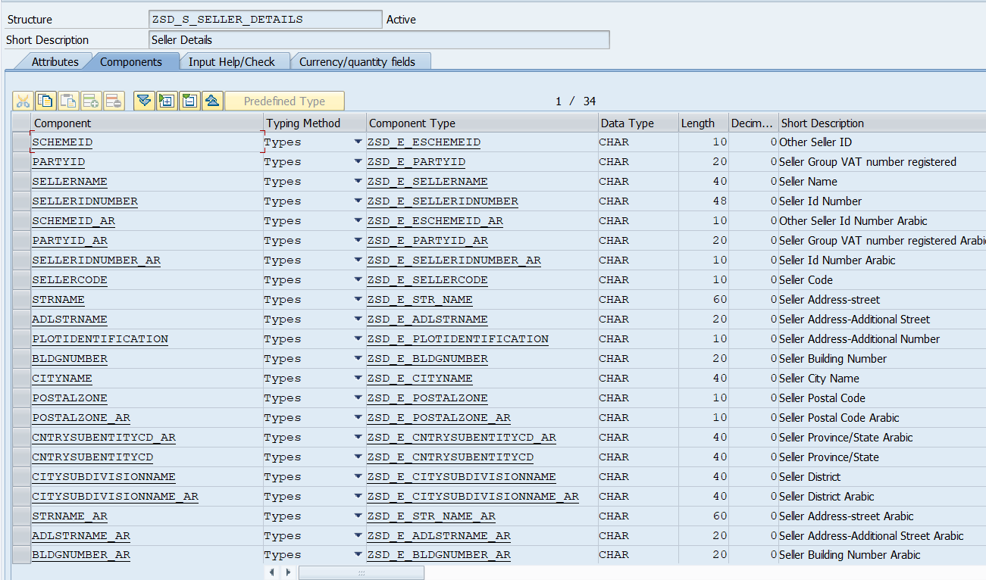

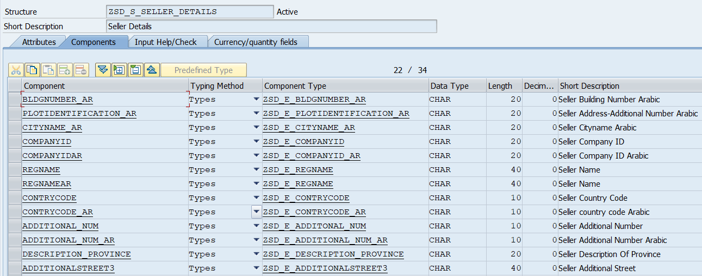

* **ZSD_S_SELLER_TAXSCEME: -** Structure for Seller Tax Scheme

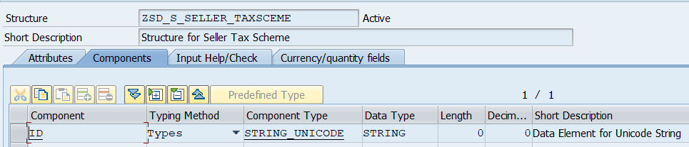

* **ZSD_S_SUPPLIER_PARTY: -** Structure for Supplier Party

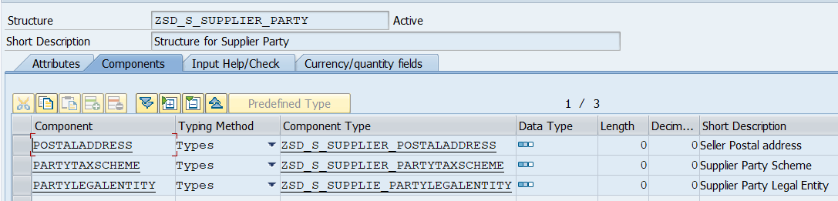

* **ZSD_S_SUPPLIER_PARTYTAXSCHEME: -** Supplier Party Scheme

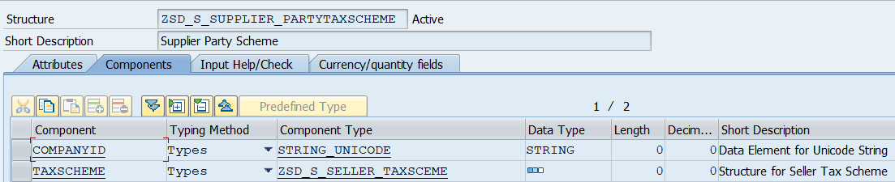

* **ZSD_S_SUPPLIER_POSTALADDRESS: -** Seller Postal address

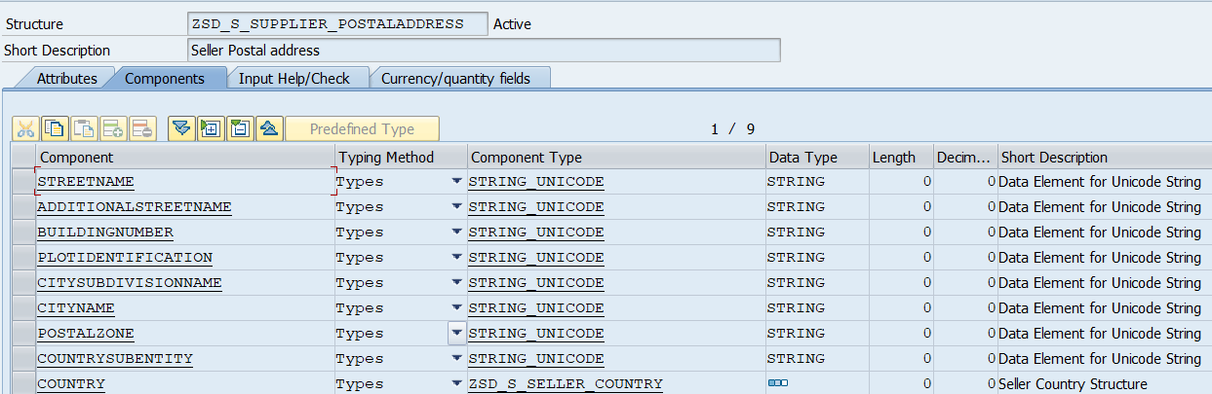

* **ZSD_S_SUPPLIE_PARTYLEGALENTITY: -** Supplier Party Legal Entity

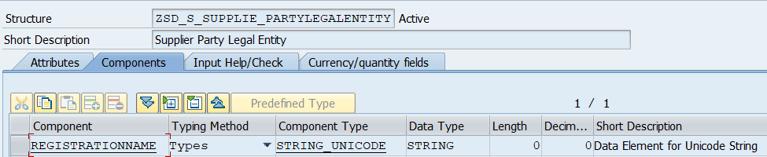

* **ZSD_S_TAXAMOUNT: -** Tax Amount

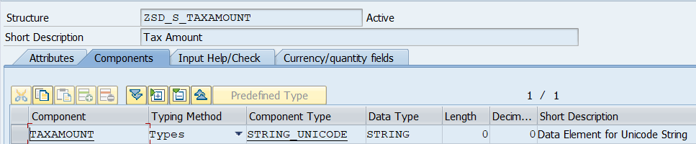

* **ZSD_S_TAXCATEGORY: -** Tax Category

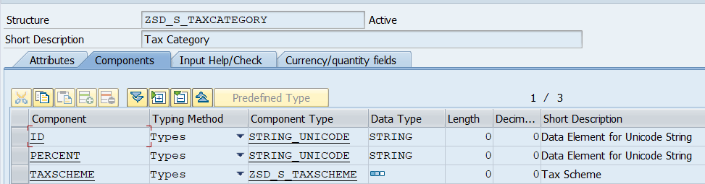

* **ZSD_S_TAXSCHEME: -** Tax Scheme

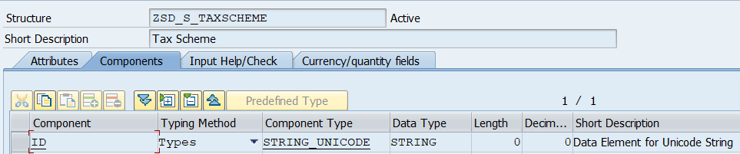

* **ZSD_S_TAXSUBTOTAL: -** Tax Subtotal

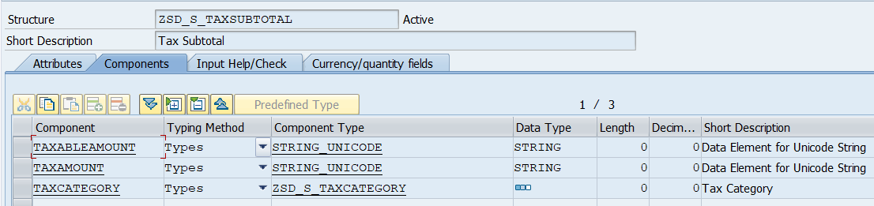

* **ZSD_S_TAXTOTAL_LINE: -** TaxTotal Line

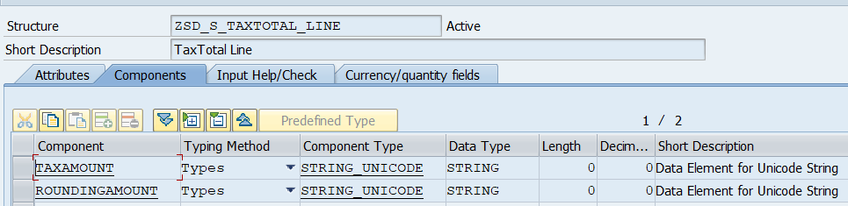

* **ZSD_S_TAX_CATEGORY: -** Tax Category

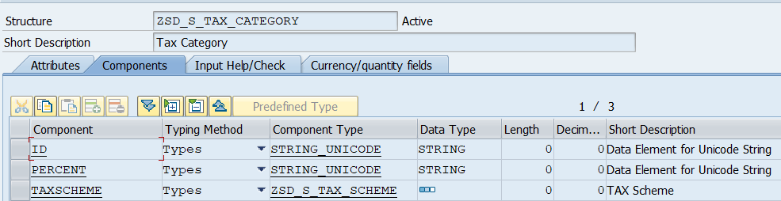

* **ZSD_S_TAX_SCHEME: -** TAX Scheme

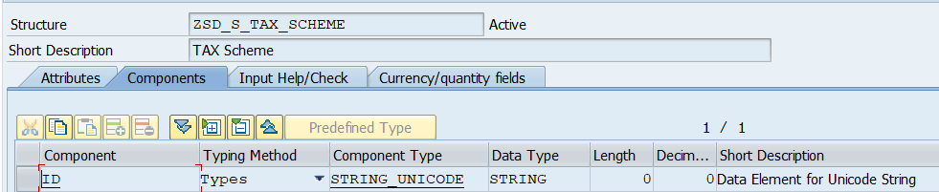

* **ZSD_S_TEMP: -** Deep Structure for testing

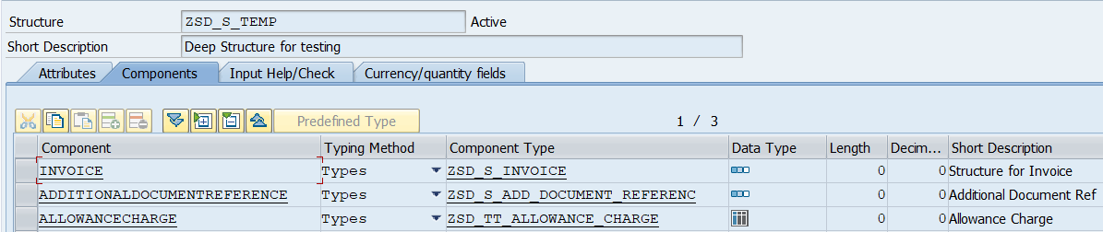

* **ZSD_S_TTAXTOTAL: -** Tax Total Structure

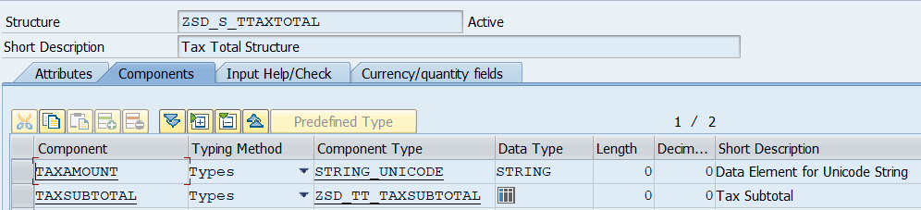

* **ZSD_S_UUID: -** UUID

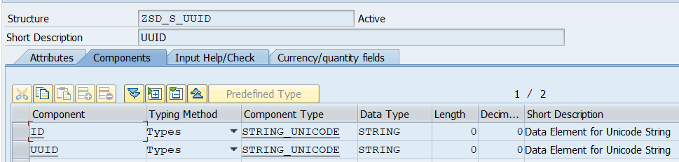

## Program Details

|  |  |  |  |  |
| --- | --- | --- | --- | --- |
| **SD Program** | **Description** | **Package** | **T-Code** | **Content File** |
| ZSD_R_EINVOICE | E-Invoice generation | ZEINV_RAK | ZSDEI |  |
| ZSDFI_R_EINVOICE | E-Invoice Cockpit (SD and FI) | ZEINV_RAK | ZEINV |  |

## Global Class details

|  |  |  |
| --- | --- | --- |
| **SD Class** | **Description** | **Package** |
| ZCL_SD_EINVOICE | Class for E-invoice | ZEINV_RAK |
| ZCL_SD_EINVOICE_CONSTANTS | Constant Class for Product types names patterns | ZEINV_RAK |

* **ZCL_SD_EINVOICE: -**

Properties: -

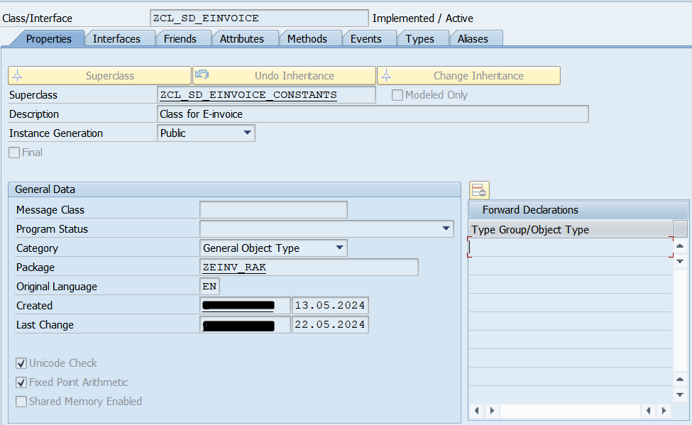

Attributes: -

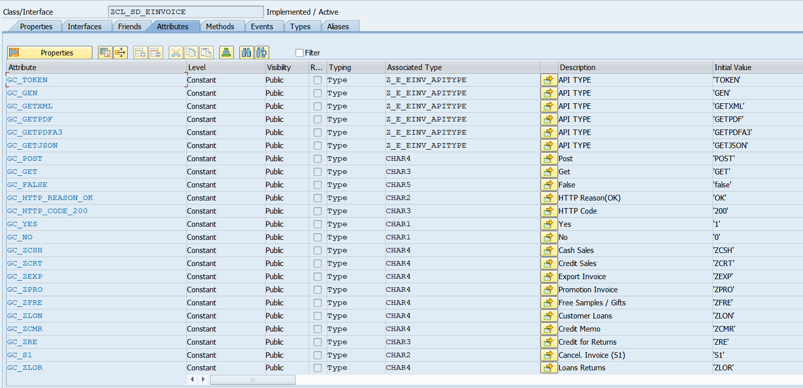

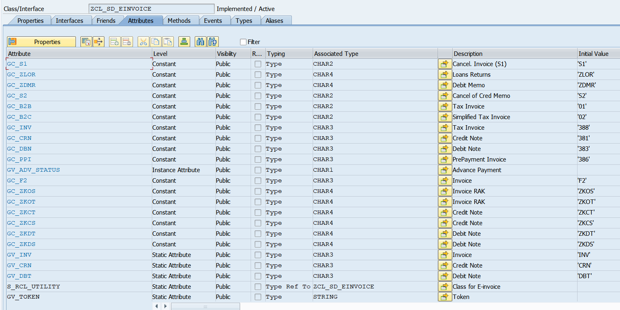

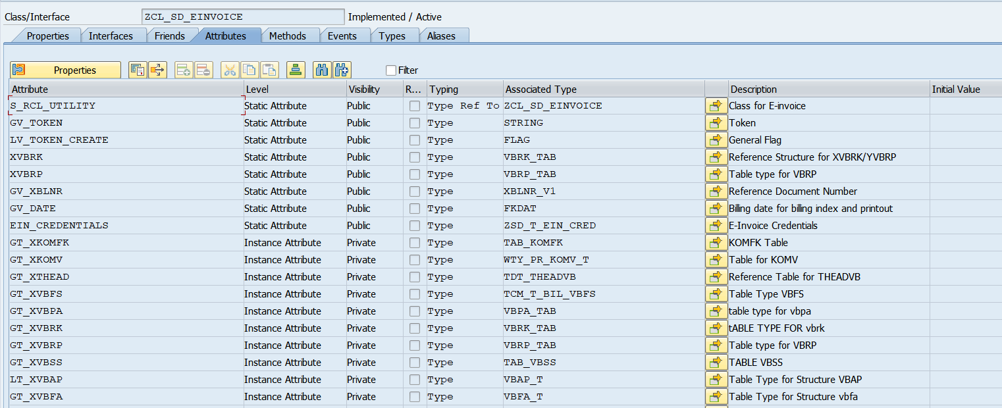

Methods: -

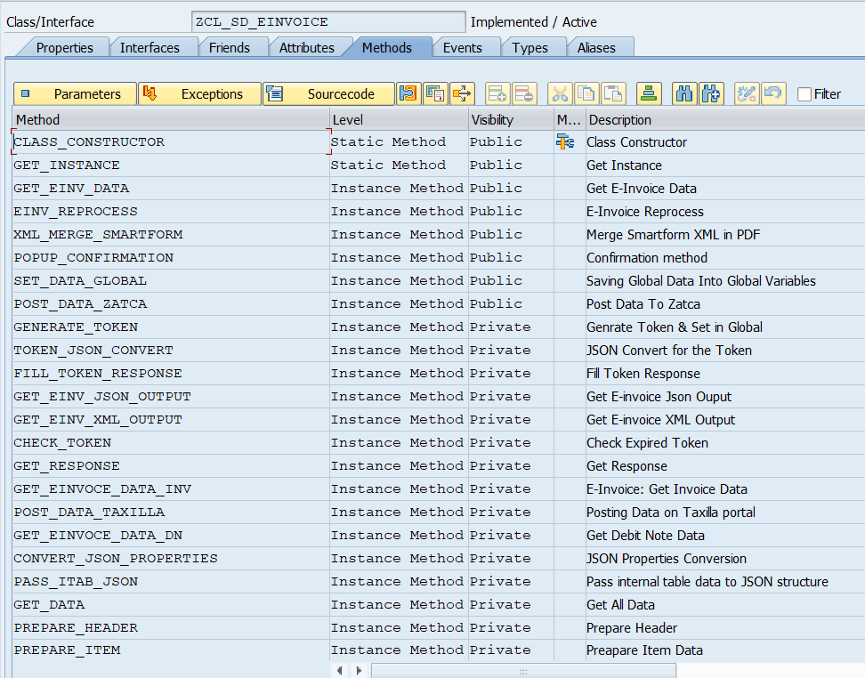

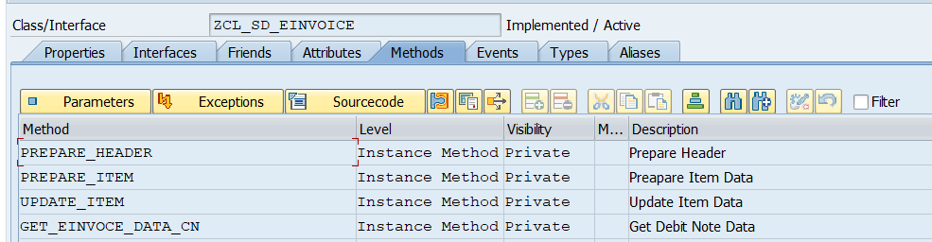

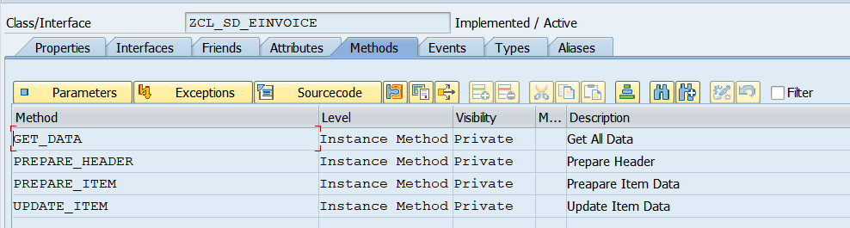

Types: -

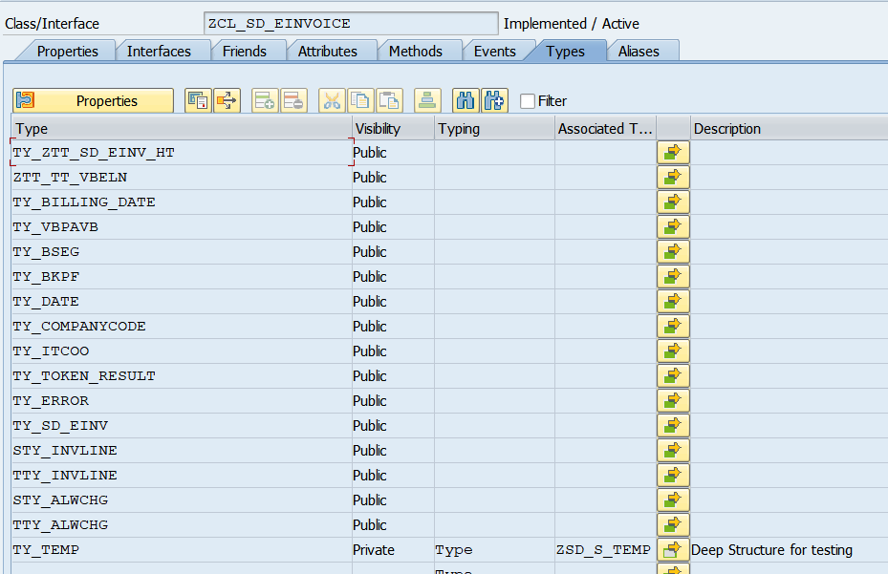

|  |  |  |
| --- | --- | --- |
| **Type** | **Associated Type** | **Content File** |
| TY_ZTT_SD_EINV_HT |  |  |
| ZTT_TT_VBELN |  |  |
| TY_BILLING_DATE |  |  |
| TY_VBPAVB |  |  |
| TY_BSEG |  |  |
| TY_BKPF |  |  |
| TY_DATE |  |  |
| TY_COMPANYCODE |  |  |
| TY_ITCOO |  |  |
| TY_TOKEN_RESULT |  |  |
| TY_ERROR |  |  |
| TY_SD_EINV |  |  |
| STY_INVLINE |  |  |
| TTY_INVLINE |  |  |
| STY_ALWCHG |  |  |
| TTY_ALWCHG |  |  |
| TY_TEMP | ZSD_S_TEMP |  |

* **Methods details of global class: ZCL_SD_EINVOICE**

|  |  |  |  |  |
| --- | --- | --- | --- | --- |
| **SD Method** | **Level** | **Visibility** | **Description** | **Content File** |
| CLASS_CONSTRUCTOR | Static Method | Public | Class Constructor |  |
| GET_INSTANCE | Static Method | Public | Get Instance |  |
| GET_EINV_DATA | Instance Method | Public | Get E-Invoice Data |  |
| EINV_REPROCESS | Instance Method | Public | E-Invoice Reprocess |  |
| XML_MERGE_SMARTFORM | Instance Method | Public | Merge Smartform XML in PDF |  |
| POPUP_CONFIRMATION | Instance Method | Public | Confirmation method |  |
| SET_DATA_GLOBAL | Instance Method | Public | Saving Global Data into Global Variables |  |
| POST_DATA_ZATCA | Instance Method | Public | Post Data to Zatca |  |
| GENERATE_TOKEN | Instance Method | Private | Generate Token & Set in Global |  |
| TOKEN_JSON_CONVERT | Instance Method | Private | JSON Convert for the Token |  |
| FILL_TOKEN_RESPONSE | Instance Method | Private | Fill Token Response |  |
| GET_EINV_JSON_OUTPUT | Instance Method | Private | Get E-invoice Json Output |  |
| GET_EINV_XML_OUTPUT | Instance Method | Private | Get E-invoice XML Output |  |
| CHECK_TOKEN | Instance Method | Private | Check Expired Token |  |
| GET_RESPONSE | Instance Method | Private | Get Response |  |
| GET_EINVOCE_DATA_INV | Instance Method | Private | E-Invoice: Get Invoice Data |  |
| POST_DATA_TAXILLA | Instance Method | Private | Posting Data on Taxilla portal |  |
| GET_EINVOCE_DATA_DN | Instance Method | Private | Get Debit Note Data |  |
| CONVERT_JSON_PROPERTIES | Instance Method | Private | JSON Properties Conversion |  |
| PASS_ITAB_JSON | Instance Method | Private | Pass internal table data to JSON structure |  |
| GET_DATA | Instance Method | Private | Get All Data |  |
| PREPARE_HEADER | Instance Method | Private | Prepare Header |  |
| PREPARE_ITEM | Instance Method | Private | Prepare Item Data |  |
| UPDATE_ITEM | Instance Method | Private | Update Item Data |  |
| GET_EINVOCE_DATA_CN | Instance Method | Private | Get Debit Note Data |  |

* **ZCL_SD_EINVOICE_CONSTANTS**

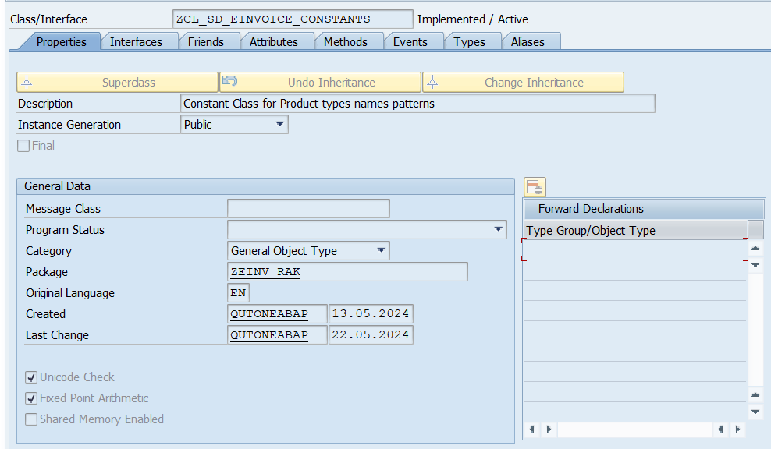

**Attributes: -**

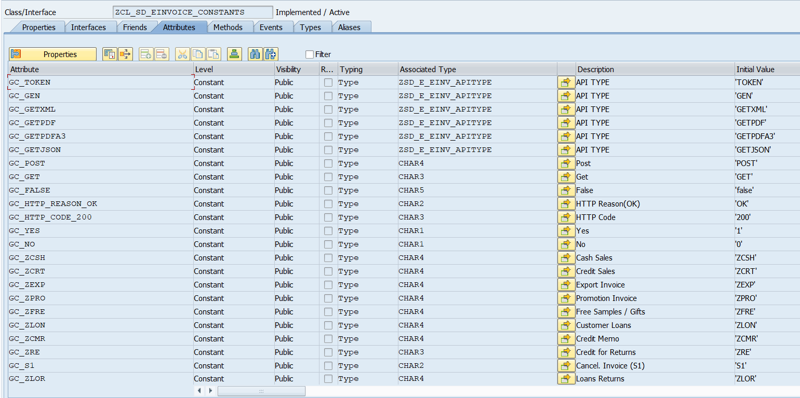

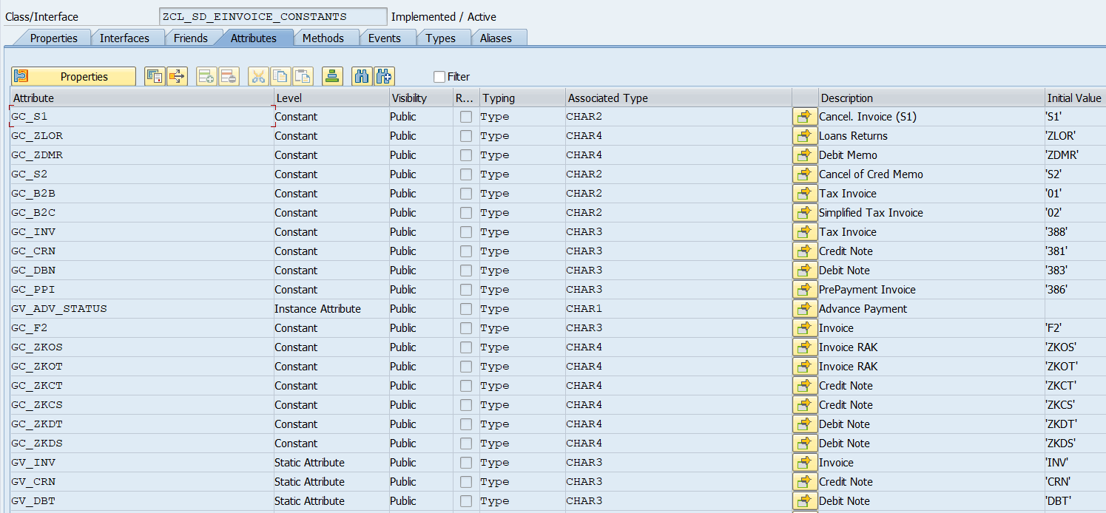

## Enhancement details:

|  |  |  |  |
| --- | --- | --- | --- |
| **Function module** | **Enhancement Implementation** | **Package** | **Content File** |
| RV_INVOICE_DOCUMENT_ADD | ZSD_ENH_EINVOICE | ZEINV_RAK |  |
| RV_INVOICE_REFRESH | ZSD_ENH_EINVOICE_GLOBAL_DATA | ZEINV_RAK |  |

## Smart form Details:

|  |  |  |
| --- | --- | --- |
| **SD Smart forms** | **Package** | **Remarks** |
|  |  | Added QA code & XML embedded in existing form |